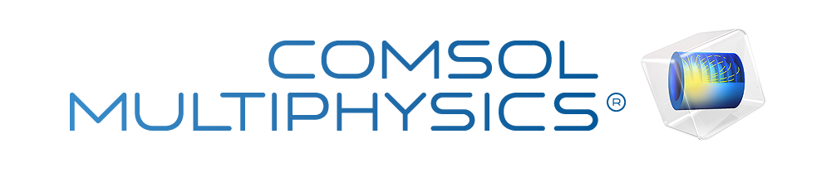

Finite Element Analysis Project Report
Finite Element analysis of Laptop stand using COMSOL Multiphysics software
Submitted to: Prof. Iniyan Thiruselvam N, Department of Mechanical Engineering
Date: 29th April, 2026

Prepared by:
1) Yash Shantanu More
2) Vaishnav Sairam
3) Jay Shantanu More
4) Kalash Jain

Contents
1. Global Definitions
1.1. Mesh Parts
2. Component 1
2.1. Definitions
2.2. Geometry 1
2.3. Materials
2.4. Solid Mechanics
2.5. Mesh 1
3. Study 1
3.1. Stationary
3.2. Solver Configurations
4. Results
4.1. Data Sets
4.2. Plot Groups

- Global Definitions
Date | Apr 29, 2026 6:53:44 PM

Global settings
Name | Untitled.mph
COMSOL version | COMSOL 5.2a (Build: 262)

Used products
COMSOL Multiphysics
MEMS Module

  - Mesh Parts
    - Mesh Part 1
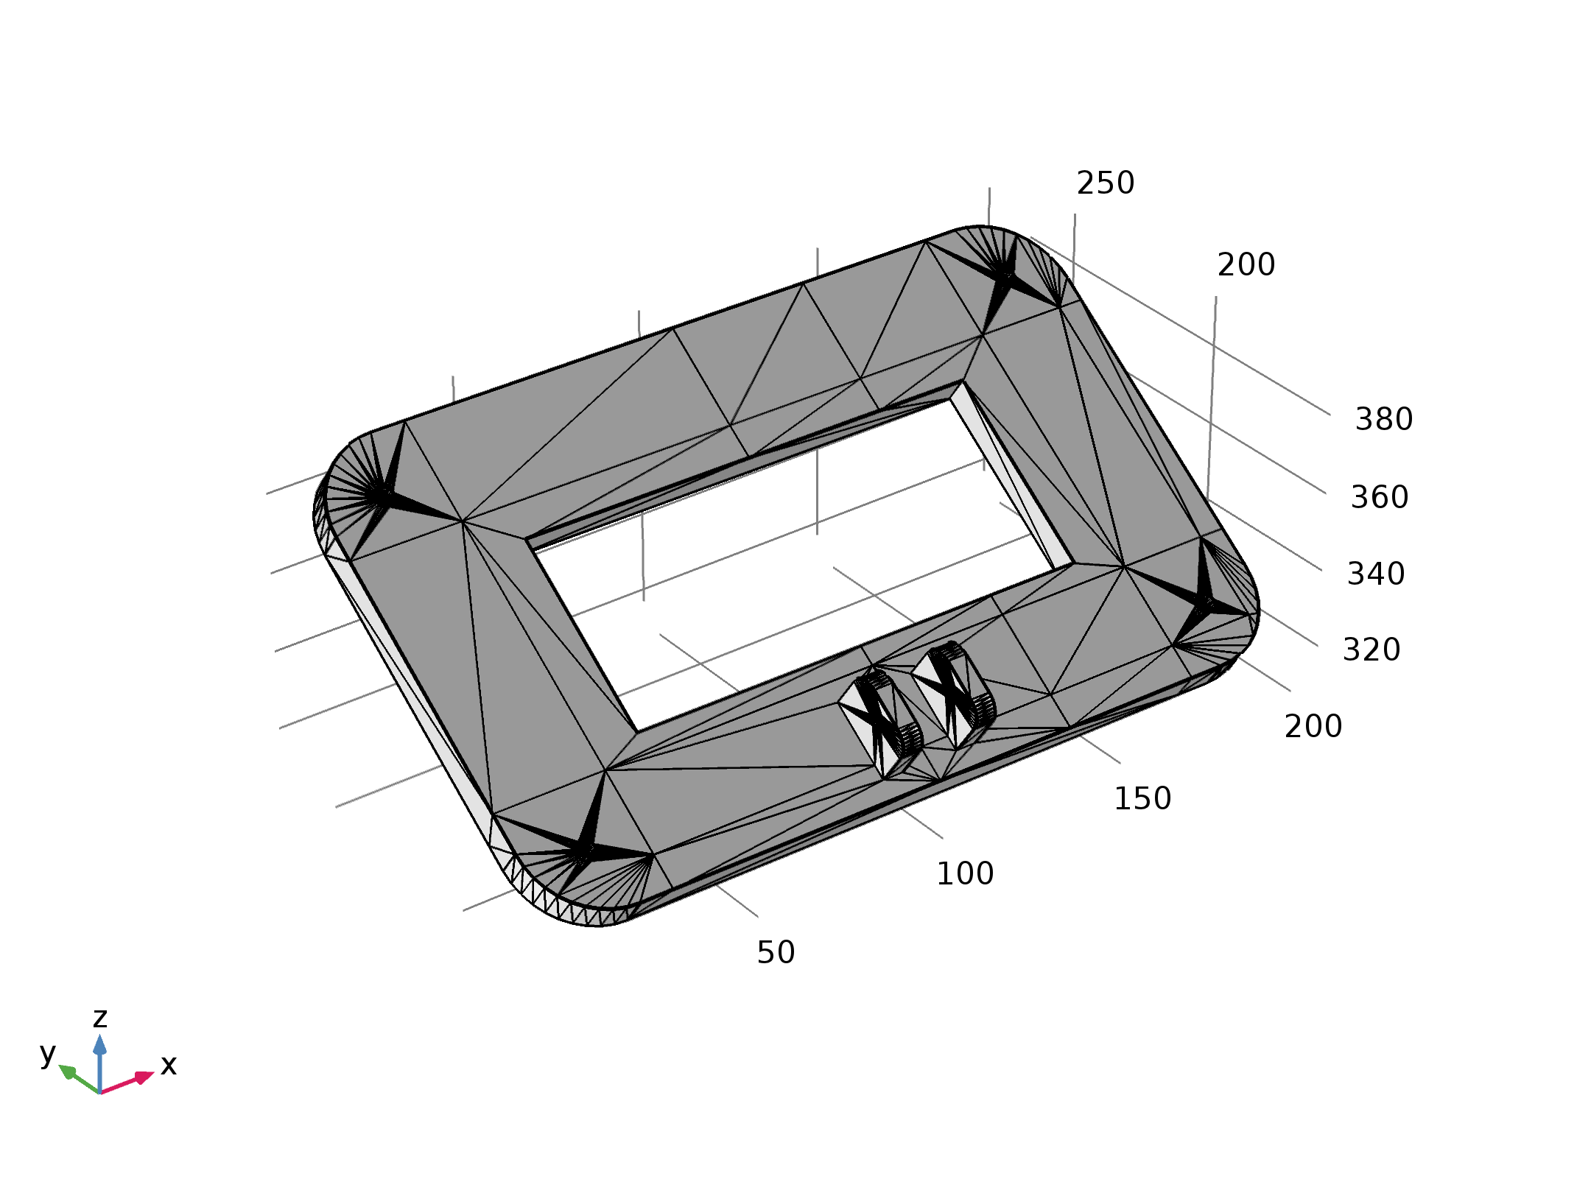
Mesh Part 1

Import 1 (imp1)
Settings
Description | Value
Source | STL/VRML file
Filename | E:\cad_lab_ansys\stl files\Final_Assembly_STL FILE - top_base_lower_bit - 1.STL

    - Mesh Part 2
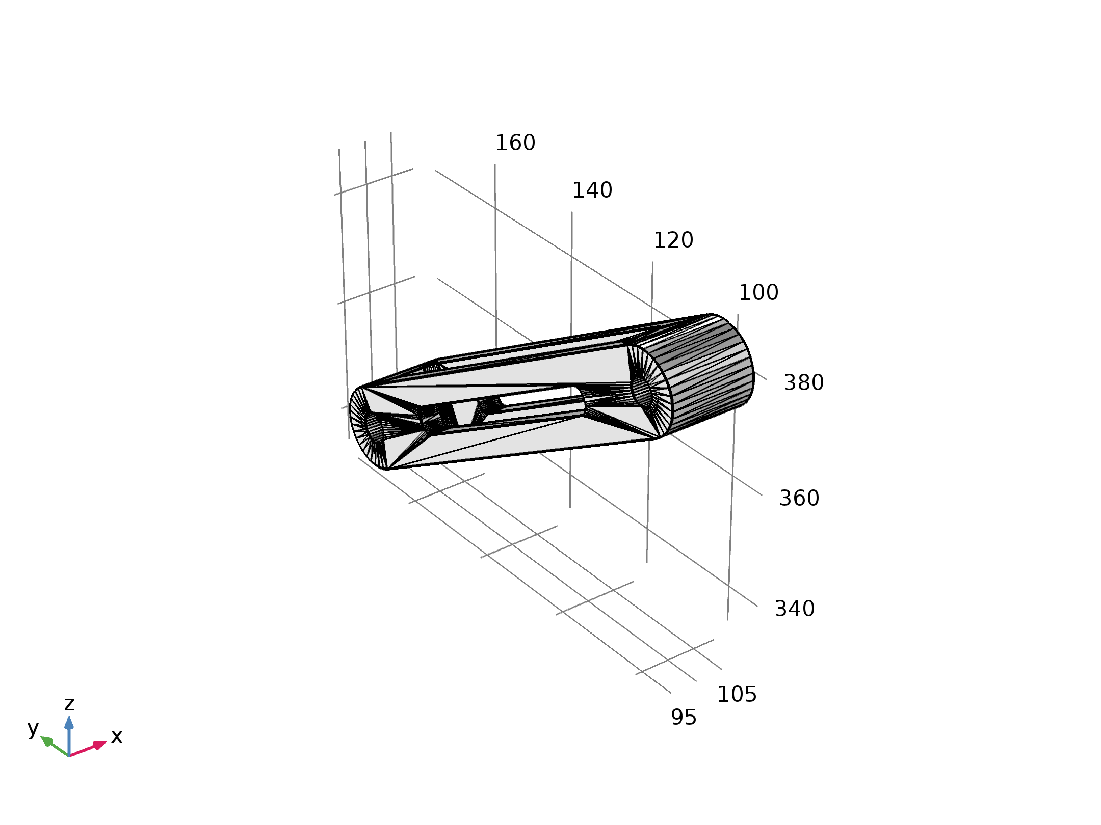
Mesh Part 2

Import 1 (imp1)
Settings
Description | Value
Source | STL/VRML file
Filename | E:\cad_lab_ansys\stl files\Final_Assembly_STL FILE - linkage-1.STL

    - Mesh Part 3
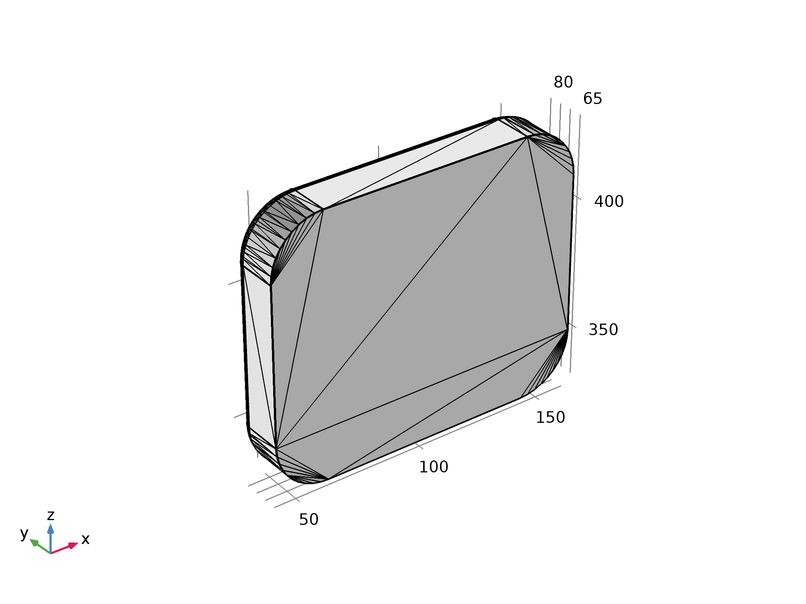
Mesh Part 3

Import 1 (imp1)
Settings
Description | Value
Source | STL/VRML file
Filename | E:\cad_lab_ansys\stl files\Final_Assembly_STL FILE - bottom_bas - 1.STL

    - Mesh Part 4
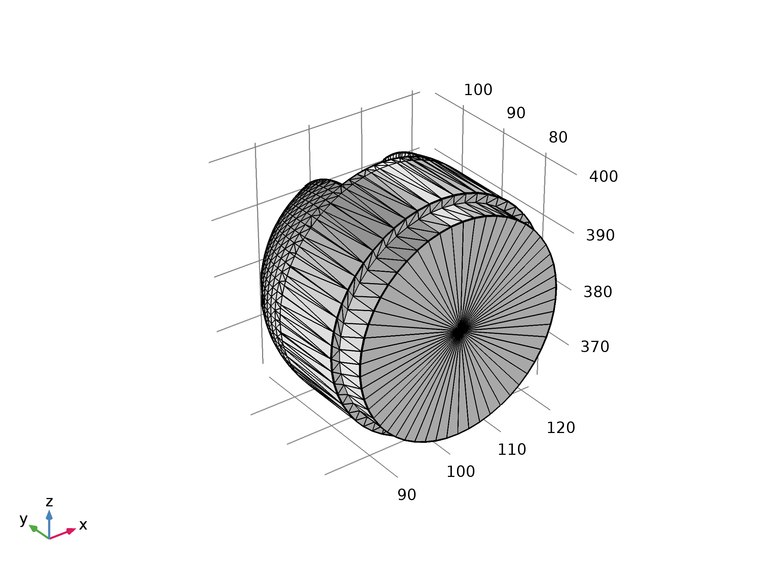
Mesh Part 4

Import 1 (imp1)
Settings
Description | Value
Source | STL/VRML file
Filename | E:\cad_lab_ansys\stl files\Final_Assembly_STL FILE - swiveling_joint - 1.STL

    - Mesh Part 5
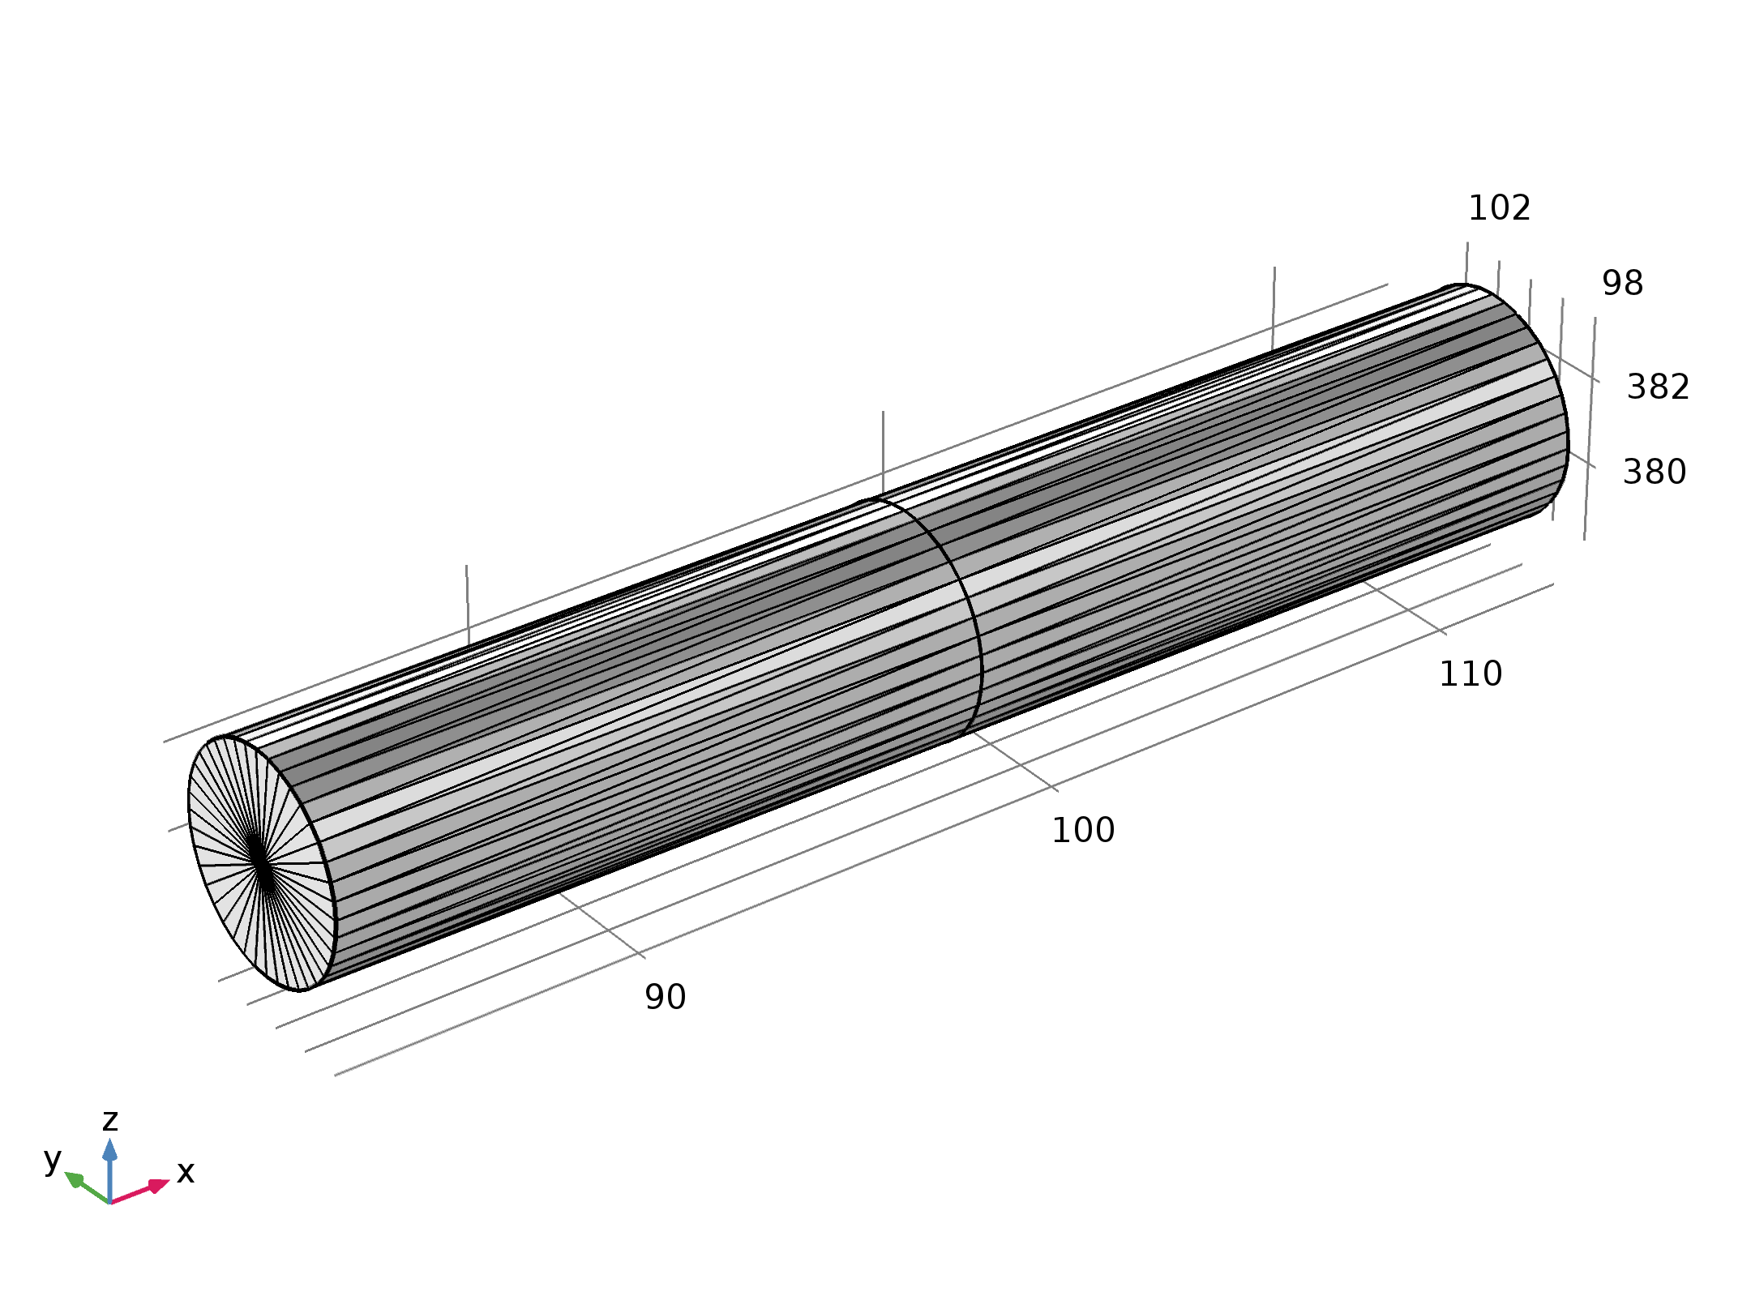
Mesh Part 5

Import 1 (imp1)
Settings
Description | Value
Source | STL/VRML file
Filename | E:\cad_lab_ansys\stl files\Final_Assembly_STL FILE - shaft_2 - 1.STL

    - Mesh Part 6
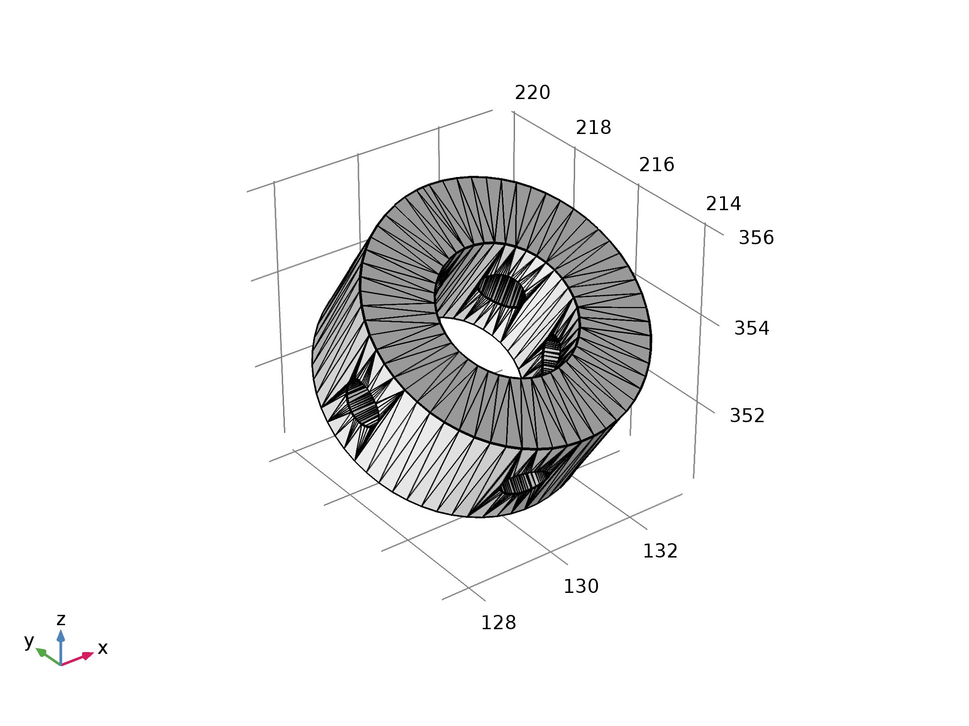
Mesh Part 6

Import 1 (imp1)
Settings
Description | Value
Source | STL/VRML file
Filename | E:\cad_lab_ansys\stl files\Final_Assembly_STL FILE - fan_assembly - 2 fan_pin - 1.STL

    - Mesh Part 7
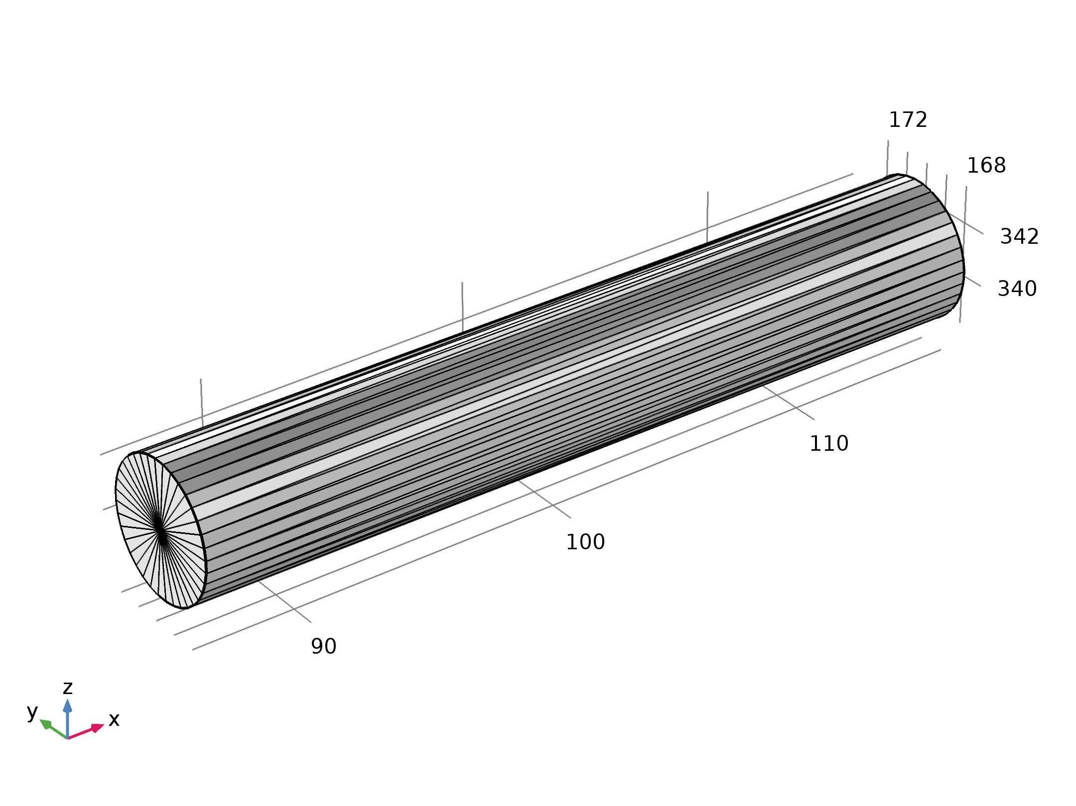
Mesh Part 7

Import 1 (imp1)
Settings
Description | Value
Source | STL/VRML file
Filename | E:\cad_lab_ansys\stl files\Final_Assembly_STL FILE - shaft - 2.STL

- Component 1
Component settings
Unit system | SI

  - Definitions
    - Pairs

Contact Pair 2
Pair type | Identity pair
Pair name | ap2

    - Coordinate Systems

Boundary System 1
Coordinate system type | Boundary system
Tag | sys1

Coordinate names
First | Second | Third
t1 | t2 | n

  - Geometry 1
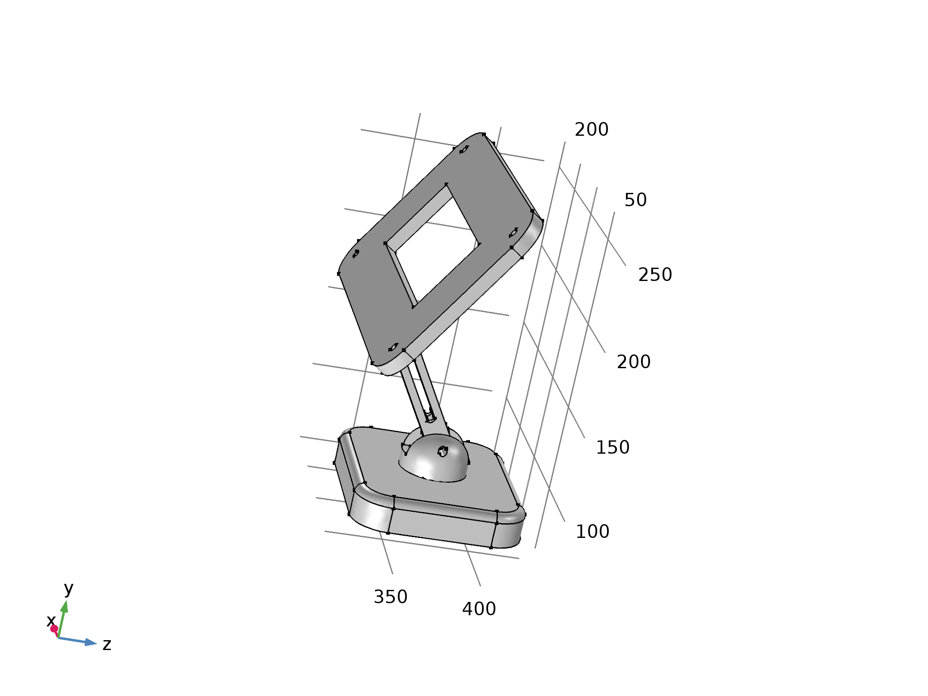
Geometry 1
Units
Length unit | mm
Angular unit | deg

Geometry statistics
Description | Value
Space dimension | 3
Number of domains | 4
Number of boundaries | 83
Number of edges | 216
Number of vertices | 158

    - Import 1 (imp1)
Settings
Description | Value
Source | Mesh or STL file
Mesh | Mesh Part 1

    - Import 2 (imp2)
Settings
Description | Value
Source | Mesh or STL file
Mesh | Mesh Part 2

    - Import 3 (imp3)
Settings
Description | Value
Source | Mesh or STL file
Mesh | Mesh Part 3

    - Import 4 (imp4)
Settings
Description | Value
Source | Mesh or STL file
Mesh | Mesh Part 4

    - Form Assembly (fin)
Settings
Description | Value
Action | Form an assembly
Split disconnected pairs | On
Pair type | Contact pair
Repair tolerance | Absolute
Absolute repair tolerance | 0.000000000000000005

  - Materials
    - Aluminum 6063-T83.1
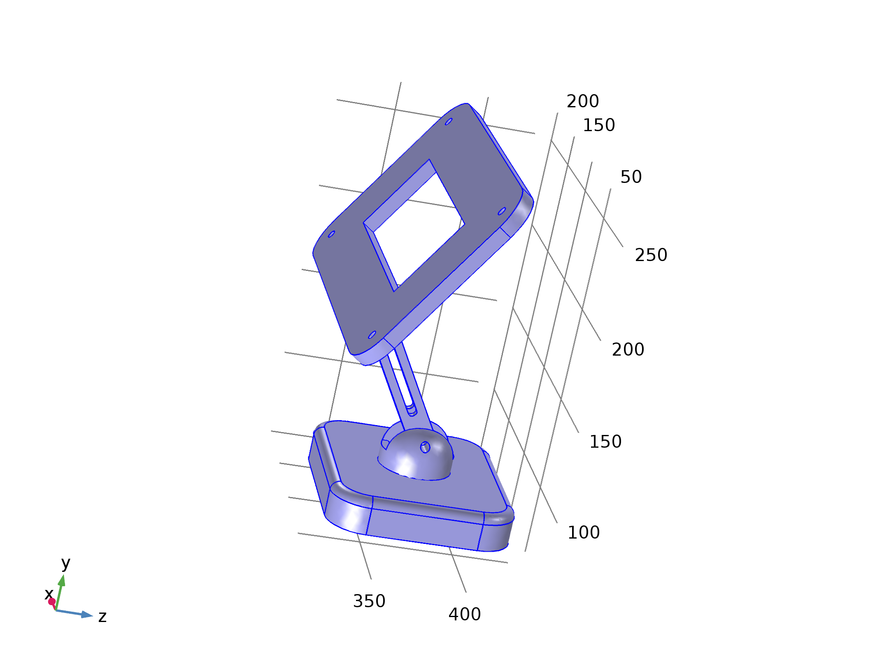
Aluminum 6063-T83.1
Selection
Geometric entity level | Domain
Selection | Domains 1–4

Material parameters
Name | Value | Unit
Density | 2700[kg/m^3] | kg/m³
Young's modulus | 69e9[Pa] | Pa
Poisson's ratio | 0.33 | 1

Basic Settings
Description | Value
Relative permeability | {{1, 0, 0}, {0, 1, 0}, {0, 0, 1}}
Electrical conductivity | {{3.030e7[S/m], 0, 0}, {0, 3.030e7[S/m], 0}, {0, 0, 3.030e7[S/m]}}
Coefficient of thermal expansion | {{23.4e-6[1/K], 0, 0}, {0, 23.4e-6[1/K], 0}, {0, 0, 23.4e-6[1/K]}}
Heat capacity at constant pressure | 900[J/(kg*K)]
Relative permittivity | {{1, 0, 0}, {0, 1, 0}, {0, 0, 1}}
Density | 2700[kg/m^3]
Thermal conductivity | {{201[W/(m*K)], 0, 0}, {0, 201[W/(m*K)], 0}, {0, 0, 201[W/(m*K)]}}

Young's modulus and Poisson's ratio Settings
Description | Value
Young's modulus | 69e9[Pa]
Poisson's ratio | 0.33

  - Solid Mechanics
Used products
COMSOL Multiphysics

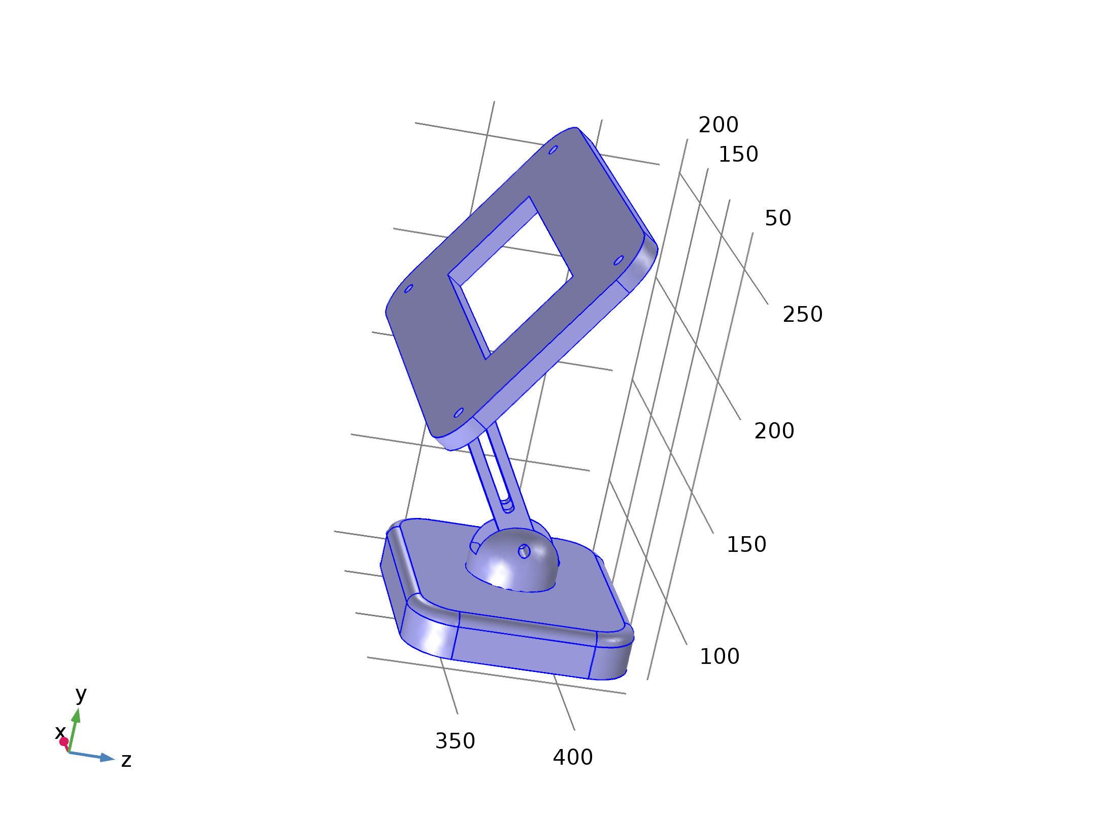
Solid Mechanics
Selection
Geometric entity level | Domain
Selection | Domains 1–4

Equations
Settings
Description | Value
Displacement field | Quadratic serendipity
Compute boundary fluxes | Off
Value type when using splitting of complex variables | Complex
Typical wave speed for perfectly matched layers | solid.cp

Variables
Name | Expression | Unit | Description | Selection
solid.nX | dnX | 1 | Normal vector, X component | Boundaries 1–83
solid.nY | dnY | 1 | Normal vector, Y component | Boundaries 1–83
solid.nZ | dnZ | 1 | Normal vector, Z component | Boundaries 1–83
solid.nx | dnx | 1 | Normal vector, x component | Boundaries 1–83
solid.ny | dny | 1 | Normal vector, y component | Boundaries 1–83
solid.nz | dnz | 1 | Normal vector, z component | Boundaries 1–83
solid.nXmesh | dnXmesh | 1 | Normal vector (mesh), X component | Boundaries 1–83
solid.nYmesh | dnYmesh | 1 | Normal vector (mesh), Y component | Boundaries 1–83
solid.nZmesh | dnZmesh | 1 | Normal vector (mesh), Z component | Boundaries 1–83
solid.nxmesh | dnxmesh | 1 | Normal vector (mesh), x component | Boundaries 1–83
solid.nymesh | dnymesh | 1 | Normal vector (mesh), y component | Boundaries 1–83
solid.nzmesh | dnzmesh | 1 | Normal vector (mesh), z component | Boundaries 1–83
solid.refpntx | 0 | m | Reference point for moment computation, x component | Global
solid.refpnty | 0 | m | Reference point for moment computation, y component | Global
solid.refpntz | 0 | m | Reference point for moment computation, z component | Global
solid.cref | solid.cp | m/s | Typical wave speed for perfectly matched layers | Domains 1–4
xt | d(x,TIME) | m/s | Mesh velocity, x component | Global
yt | d(y,TIME) | m/s | Mesh velocity, y component | Global
zt | d(z,TIME) | m/s | Mesh velocity, z component | Global

    - Linear Elastic Material 1
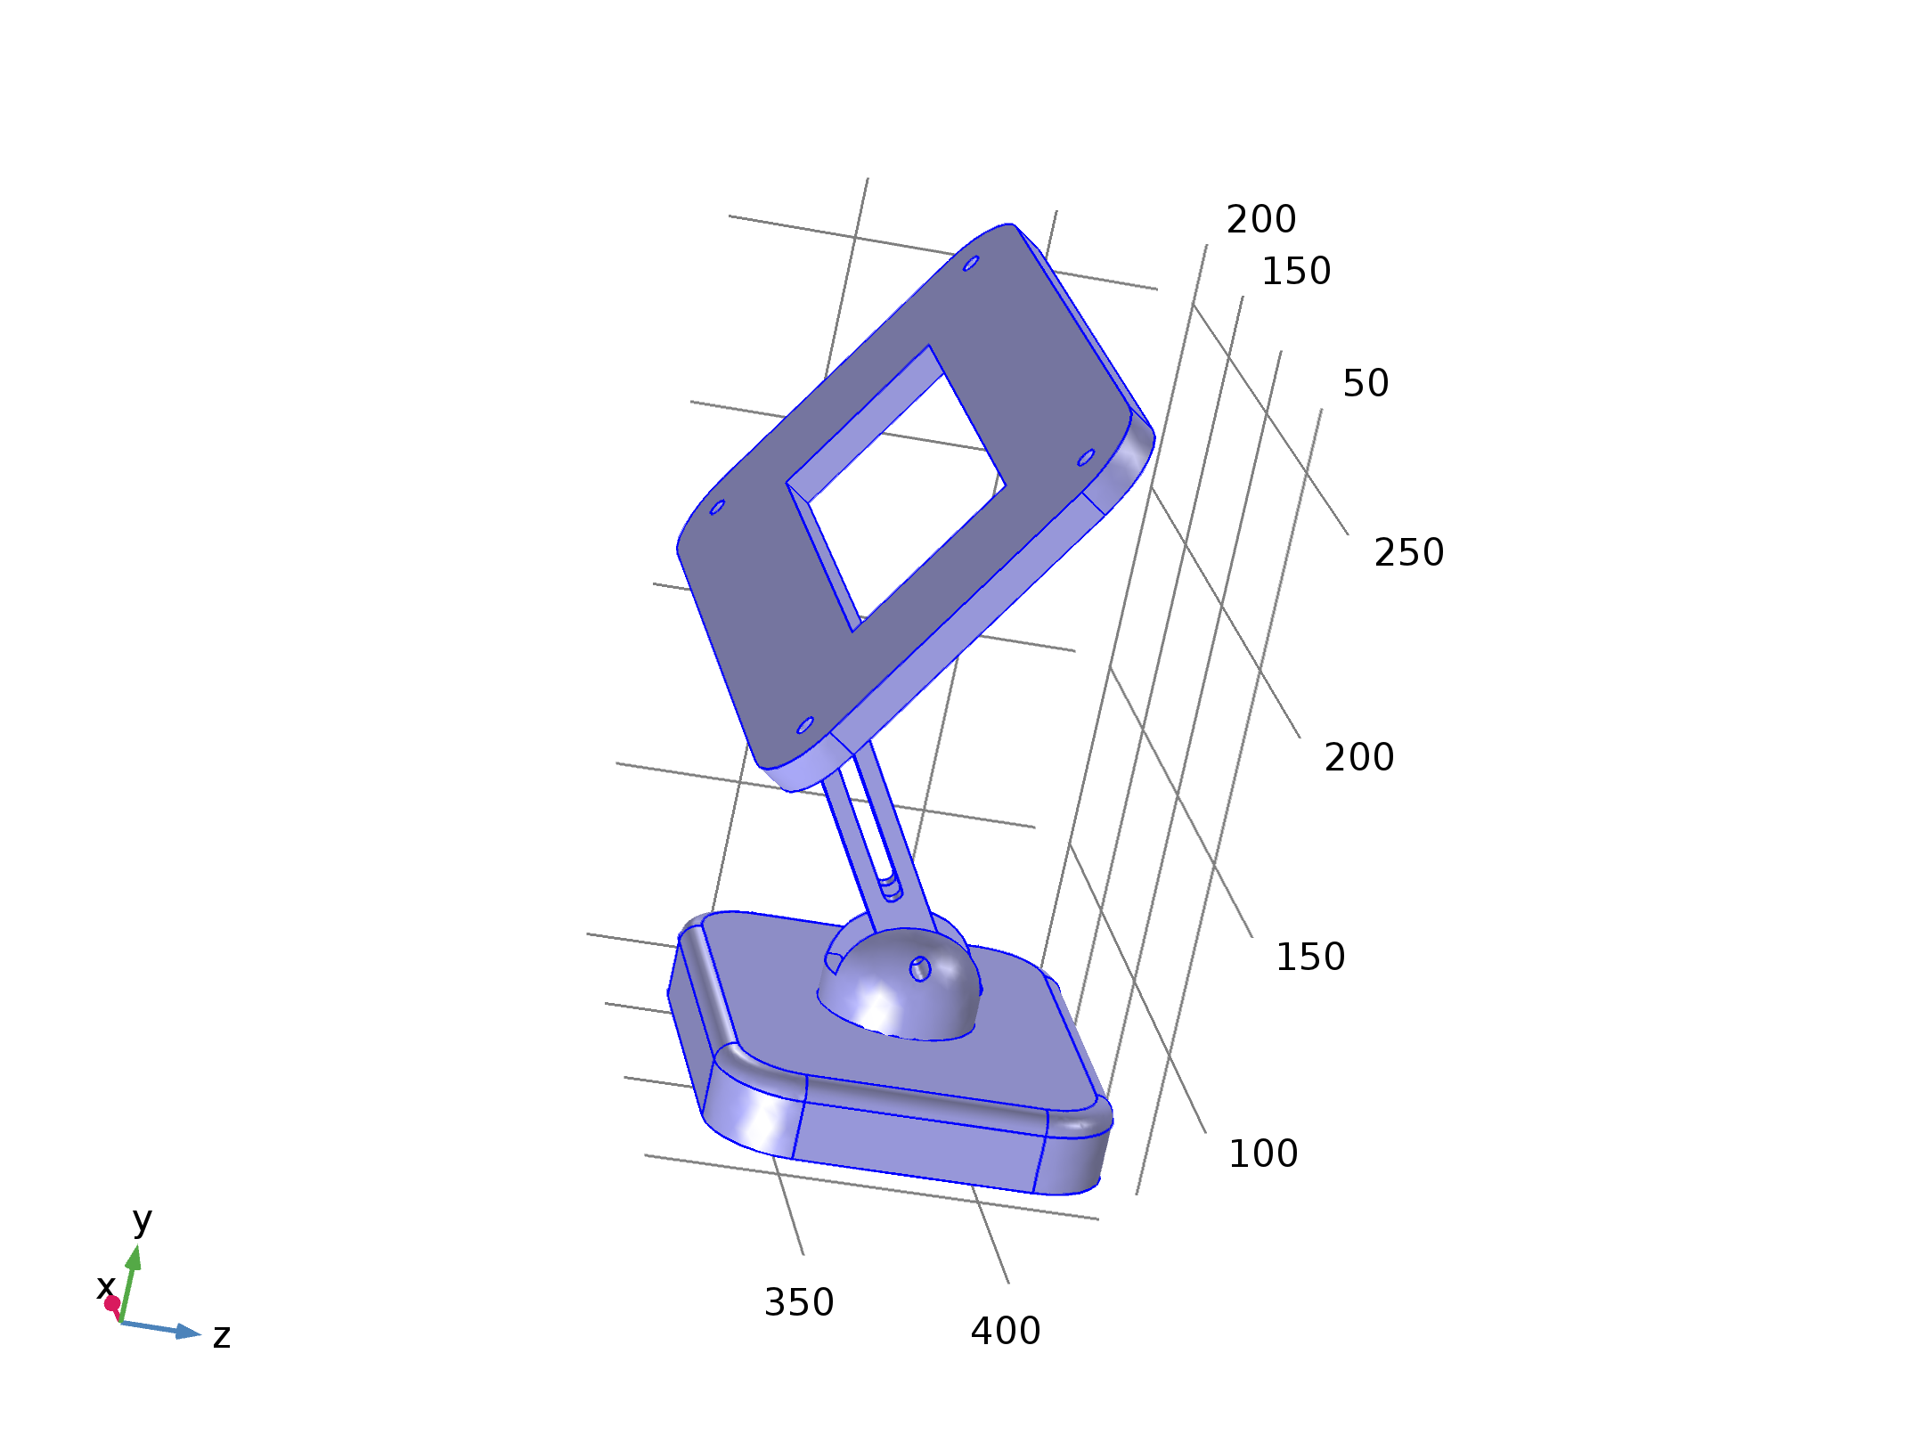
Linear Elastic Material 1
Selection
Geometric entity level | Domain
Selection | Domains 1–4

Equations
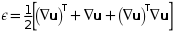
Settings
Description | Value
Nearly incompressible material | Off
Solid model | Isotropic
Specify | Young's modulus and Poisson's ratio
Young's modulus | From material
Poisson's ratio | From material
Density | From material
Force linear strains | Off
Calculate dissipated energy | Off

Properties from material
Property | Material | Property group
Young's modulus | Aluminum 6063-T83.1 | Young's modulus and Poisson's ratio
Poisson's ratio | Aluminum 6063-T83.1 | Young's modulus and Poisson's ratio
Density | Aluminum 6063-T83.1 | Basic

Variables
Name | Expression | Unit | Description | Selection
solid.rho | material.rho | kg/m³ | Density | Domains 1–4
solid.Qh | 0 | W/m³ | Total power dissipation density | Domains 1–4
uTXt | uTXTIME | 1/s | Tangential gradient of u, X component, first time derivative | Boundaries 1–83
uTYt | uTYTIME | 1/s | Tangential gradient of u, Y component, first time derivative | Boundaries 1–83
uTZt | uTZTIME | 1/s | Tangential gradient of u, Z component, first time derivative | Boundaries 1–83
uTXtt | uTXTIMETIME | 1/s² | Tangential gradient of u, X component, second time derivative | Boundaries 1–83
uTYtt | uTYTIMETIME | 1/s² | Tangential gradient of u, Y component, second time derivative | Boundaries 1–83
uTZtt | uTZTIMETIME | 1/s² | Tangential gradient of u, Z component, second time derivative | Boundaries 1–83
uXt | uXTIME | 1/s | Gradient of u, X component, first time derivative | Domains 1–4
uYt | uYTIME | 1/s | Gradient of u, Y component, first time derivative | Domains 1–4
uZt | uZTIME | 1/s | Gradient of u, Z component, first time derivative | Domains 1–4
uXtt | uXTIMETIME | 1/s² | Gradient of u, X component, second time derivative | Domains 1–4
uYtt | uYTIMETIME | 1/s² | Gradient of u, Y component, second time derivative | Domains 1–4
uZtt | uZTIMETIME | 1/s² | Gradient of u, Z component, second time derivative | Domains 1–4
vTXt | vTXTIME | 1/s | Tangential gradient of v, X component, first time derivative | Boundaries 1–83
vTYt | vTYTIME | 1/s | Tangential gradient of v, Y component, first time derivative | Boundaries 1–83
vTZt | vTZTIME | 1/s | Tangential gradient of v, Z component, first time derivative | Boundaries 1–83
vTXtt | vTXTIMETIME | 1/s² | Tangential gradient of v, X component, second time derivative | Boundaries 1–83
vTYtt | vTYTIMETIME | 1/s² | Tangential gradient of v, Y component, second time derivative | Boundaries 1–83
vTZtt | vTZTIMETIME | 1/s² | Tangential gradient of v, Z component, second time derivative | Boundaries 1–83
vXt | vXTIME | 1/s | Gradient of v, X component, first time derivative | Domains 1–4
vYt | vYTIME | 1/s | Gradient of v, Y component, first time derivative | Domains 1–4
vZt | vZTIME | 1/s | Gradient of v, Z component, first time derivative | Domains 1–4
vXtt | vXTIMETIME | 1/s² | Gradient of v, X component, second time derivative | Domains 1–4
vYtt | vYTIMETIME | 1/s² | Gradient of v, Y component, second time derivative | Domains 1–4
vZtt | vZTIMETIME | 1/s² | Gradient of v, Z component, second time derivative | Domains 1–4
wTXt | wTXTIME | 1/s | Tangential gradient of w, X component, first time derivative | Boundaries 1–83
wTYt | wTYTIME | 1/s | Tangential gradient of w, Y component, first time derivative | Boundaries 1–83
wTZt | wTZTIME | 1/s | Tangential gradient of w, Z component, first time derivative | Boundaries 1–83
wTXtt | wTXTIMETIME | 1/s² | Tangential gradient of w, X component, second time derivative | Boundaries 1–83
wTYtt | wTYTIMETIME | 1/s² | Tangential gradient of w, Y component, second time derivative | Boundaries 1–83
wTZtt | wTZTIMETIME | 1/s² | Tangential gradient of w, Z component, second time derivative | Boundaries 1–83
wXt | wXTIME | 1/s | Gradient of w, X component, first time derivative | Domains 1–4
wYt | wYTIME | 1/s | Gradient of w, Y component, first time derivative | Domains 1–4
wZt | wZTIME | 1/s | Gradient of w, Z component, first time derivative | Domains 1–4
wXtt | wXTIMETIME | 1/s² | Gradient of w, X component, second time derivative | Domains 1–4
wYtt | wYTIMETIME | 1/s² | Gradient of w, Y component, second time derivative | Domains 1–4
wZtt | wZTIMETIME | 1/s² | Gradient of w, Z component, second time derivative | Domains 1–4
ut | uTIME | m/s | Structural velocity field, X component | Domains 1–4
vt | vTIME | m/s | Structural velocity field, Y component | Domains 1–4
wt | wTIME | m/s | Structural velocity field, Z component | Domains 1–4
utt | uTIMETIME | m/s² | Acceleration field, X component | Domains 1–4
vtt | vTIMETIME | m/s² | Acceleration field, Y component | Domains 1–4
wtt | wTIMETIME | m/s² | Acceleration field, Z component | Domains 1–4
solid.gradUxX | uX | 1 | Displacement gradient, xX component | Domains 1–4
solid.gradUyX | vX | 1 | Displacement gradient, yX component | Domains 1–4
solid.gradUzX | wX | 1 | Displacement gradient, zX component | Domains 1–4
solid.gradUxY | uY | 1 | Displacement gradient, xY component | Domains 1–4
solid.gradUyY | vY | 1 | Displacement gradient, yY component | Domains 1–4
solid.gradUzY | wY | 1 | Displacement gradient, zY component | Domains 1–4
solid.gradUxZ | uZ | 1 | Displacement gradient, xZ component | Domains 1–4
solid.gradUyZ | vZ | 1 | Displacement gradient, yZ component | Domains 1–4
solid.gradUzZ | wZ | 1 | Displacement gradient, zZ component | Domains 1–4
solid.FdxX | 1+solid.gradUxX | 1 | Deformation gradient, xX component | Domains 1–4
solid.FdyX | solid.gradUyX | 1 | Deformation gradient, yX component | Domains 1–4
solid.FdzX | solid.gradUzX | 1 | Deformation gradient, zX component | Domains 1–4
solid.FdxY | solid.gradUxY | 1 | Deformation gradient, xY component | Domains 1–4
solid.FdyY | 1+solid.gradUyY | 1 | Deformation gradient, yY component | Domains 1–4
solid.FdzY | solid.gradUzY | 1 | Deformation gradient, zY component | Domains 1–4
solid.FdxZ | solid.gradUxZ | 1 | Deformation gradient, xZ component | Domains 1–4
solid.FdyZ | solid.gradUyZ | 1 | Deformation gradient, yZ component | Domains 1–4
solid.FdzZ | 1+solid.gradUzZ | 1 | Deformation gradient, zZ component | Domains 1–4
solid.Fdlx1 | solid.FdxX | 1 | Deformation gradient, local, x1 component | Domains 1–4
solid.Fdly1 | solid.FdyX | 1 | Deformation gradient, local, y1 component | Domains 1–4
solid.Fdlz1 | solid.FdzX | 1 | Deformation gradient, local, z1 component | Domains 1–4
solid.Fdlx2 | solid.FdxY | 1 | Deformation gradient, local, x2 component | Domains 1–4
solid.Fdly2 | solid.FdyY | 1 | Deformation gradient, local, y2 component | Domains 1–4
solid.Fdlz2 | solid.FdzY | 1 | Deformation gradient, local, z2 component | Domains 1–4
solid.Fdlx3 | solid.FdxZ | 1 | Deformation gradient, local, x3 component | Domains 1–4
solid.Fdly3 | solid.FdyZ | 1 | Deformation gradient, local, y3 component | Domains 1–4
solid.Fdlz3 | solid.FdzZ | 1 | Deformation gradient, local, z3 component | Domains 1–4
solid.D11 | solid.E*(1-solid.nu)/((1+solid.nu)*(1-2*solid.nu)) | Pa | Elasticity matrix, 11 component | Domains 1–4
solid.D12 | solid.E*solid.nu/((1+solid.nu)*(1-2*solid.nu)) | Pa | Elasticity matrix, 12 component | Domains 1–4
solid.D13 | solid.E*solid.nu/((1+solid.nu)*(1-2*solid.nu)) | Pa | Elasticity matrix, 13 component | Domains 1–4
solid.D14 | 0 | Pa | Elasticity matrix, 14 component | Domains 1–4
solid.D15 | 0 | Pa | Elasticity matrix, 15 component | Domains 1–4
solid.D16 | 0 | Pa | Elasticity matrix, 16 component | Domains 1–4
solid.D22 | solid.E*(1-solid.nu)/((1+solid.nu)*(1-2*solid.nu)) | Pa | Elasticity matrix, 22 component | Domains 1–4
solid.D23 | solid.E*solid.nu/((1+solid.nu)*(1-2*solid.nu)) | Pa | Elasticity matrix, 23 component | Domains 1–4
solid.D24 | 0 | Pa | Elasticity matrix, 24 component | Domains 1–4
solid.D25 | 0 | Pa | Elasticity matrix, 25 component | Domains 1–4
solid.D26 | 0 | Pa | Elasticity matrix, 26 component | Domains 1–4
solid.D33 | solid.E*(1-solid.nu)/((1+solid.nu)*(1-2*solid.nu)) | Pa | Elasticity matrix, 33 component | Domains 1–4
solid.D34 | 0 | Pa | Elasticity matrix, 34 component | Domains 1–4
solid.D35 | 0 | Pa | Elasticity matrix, 35 component | Domains 1–4
solid.D36 | 0 | Pa | Elasticity matrix, 36 component | Domains 1–4
solid.D44 | 0.5*solid.E/(1+solid.nu) | Pa | Elasticity matrix, 44 component | Domains 1–4
solid.D45 | 0 | Pa | Elasticity matrix, 45 component | Domains 1–4
solid.D46 | 0 | Pa | Elasticity matrix, 46 component | Domains 1–4
solid.D55 | 0.5*solid.E/(1+solid.nu) | Pa | Elasticity matrix, 55 component | Domains 1–4
solid.D56 | 0 | Pa | Elasticity matrix, 56 component | Domains 1–4
solid.D66 | 0.5*solid.E/(1+solid.nu) | Pa | Elasticity matrix, 66 component | Domains 1–4
solid.K | solid.E/(3*(1-2*solid.nu)) | N/m² | Bulk modulus | Domains 1–4
solid.Eequ | solid.E | Pa | Equivalent Young's modulus | Domains 1–4
solid.nuequ | solid.nu | 1 | Equivalent Poisson's ratio | Domains 1–4
solid.Gequ | solid.G | N/m² | Equivalent shear modulus | Domains 1–4
solid.cp | sqrt((solid.K+4*solid.G/3)/solid.rho) | m/s | Pressure-wave speed | Domains 1–4
solid.cs | sqrt(solid.G/solid.rho) | m/s | Shear-wave speed | Domains 1–4
solid.E | material.E | Pa | Young's modulus | Domains 1–4
solid.nu | material.nu | 1 | Poisson's ratio | Domains 1–4
solid.G | 0.5*solid.E/(1+solid.nu) | N/m² | Shear modulus | Domains 1–4
solid.lambLame | solid.E*solid.nu/((1+solid.nu)*(1-2*solid.nu)) | N/m² | Lamé parameter λ | Domains 1–4
solid.muLame | 0.5*solid.E/(1+solid.nu) | N/m² | Lamé parameter μ | Domains 1–4
solid.Cgl11 | solid.D11+solid.D12+solid.D13 | Pa | C:g tensor, local coordinate system, 11 component | Domains 1–4
solid.Cgl12 | solid.D14+solid.D24+solid.D34 | Pa | C:g tensor, local coordinate system, 12 component | Domains 1–4
solid.Cgl13 | solid.D16+solid.D26+solid.D36 | Pa | C:g tensor, local coordinate system, 13 component | Domains 1–4
solid.Cgl22 | solid.D12+solid.D22+solid.D23 | Pa | C:g tensor, local coordinate system, 22 component | Domains 1–4
solid.Cgl23 | solid.D15+solid.D25+solid.D35 | Pa | C:g tensor, local coordinate system, 23 component | Domains 1–4
solid.Cgl33 | solid.D13+solid.D23+solid.D33 | Pa | C:g tensor, local coordinate system, 33 component | Domains 1–4
solid.eXX | 0.5*(2*uX+uX^2+vX^2+wX^2) | 1 | Strain tensor, XX component | Domains 1–4
solid.eXY | 0.5*(uY+vX+uX*uY+vX*vY+wX*wY) | 1 | Strain tensor, XY component | Domains 1–4
solid.eXZ | 0.5*(uZ+wX+uX*uZ+vX*vZ+wX*wZ) | 1 | Strain tensor, XZ component | Domains 1–4
solid.eYY | 0.5*(2*vY+uY^2+vY^2+wY^2) | 1 | Strain tensor, YY component | Domains 1–4
solid.eYZ | 0.5*(vZ+wY+uY*uZ+vY*vZ+wY*wZ) | 1 | Strain tensor, YZ component | Domains 1–4
solid.eZZ | 0.5*(2*wZ+uZ^2+vZ^2+wZ^2) | 1 | Strain tensor, ZZ component | Domains 1–4
solid.el11 | solid.eXX | 1 | Strain tensor, local coordinate system, 11 component | Domains 1–4
solid.el12 | solid.eXY | 1 | Strain tensor, local coordinate system, 12 component | Domains 1–4
solid.el13 | solid.eXZ | 1 | Strain tensor, local coordinate system, 13 component | Domains 1–4
solid.el22 | solid.eYY | 1 | Strain tensor, local coordinate system, 22 component | Domains 1–4
solid.el23 | solid.eYZ | 1 | Strain tensor, local coordinate system, 23 component | Domains 1–4
solid.el33 | solid.eZZ | 1 | Strain tensor, local coordinate system, 33 component | Domains 1–4
solid.eel11 | solid.el11-solid.eil11-solid.eiel11 | 1 | Elastic strain tensor, local coordinate system, 11 component | Domains 1–4
solid.eel12 | solid.el12-solid.eil12-solid.eiel12 | 1 | Elastic strain tensor, local coordinate system, 12 component | Domains 1–4
solid.eel13 | solid.el13-solid.eil13-solid.eiel13 | 1 | Elastic strain tensor, local coordinate system, 13 component | Domains 1–4
solid.eel22 | solid.el22-solid.eil22-solid.eiel22 | 1 | Elastic strain tensor, local coordinate system, 22 component | Domains 1–4
solid.eel23 | solid.el23-solid.eil23-solid.eiel23 | 1 | Elastic strain tensor, local coordinate system, 23 component | Domains 1–4
solid.eel33 | solid.el33-solid.eil33-solid.eiel33 | 1 | Elastic strain tensor, local coordinate system, 33 component | Domains 1–4
solid.Cel11 | 1+2*solid.eel11 | 1 | Elastic Cauchy-Green tensor, local coordinate system, 11 component | Domains 1–4
solid.Cel12 | 2*solid.eel12 | 1 | Elastic Cauchy-Green tensor, local coordinate system, 12 component | Domains 1–4
solid.Cel13 | 2*solid.eel13 | 1 | Elastic Cauchy-Green tensor, local coordinate system, 13 component | Domains 1–4
solid.Cel22 | 1+2*solid.eel22 | 1 | Elastic Cauchy-Green tensor, local coordinate system, 22 component | Domains 1–4
solid.Cel23 | 2*solid.eel23 | 1 | Elastic Cauchy-Green tensor, local coordinate system, 23 component | Domains 1–4
solid.Cel33 | 1+2*solid.eel33 | 1 | Elastic Cauchy-Green tensor, local coordinate system, 33 component | Domains 1–4
solid.eil11 | 0 | 1 | Initial strain tensor, local coordinate system, 11 component | Domains 1–4
solid.eil12 | 0 | 1 | Initial strain tensor, local coordinate system, 12 component | Domains 1–4
solid.eil13 | 0 | 1 | Initial strain tensor, local coordinate system, 13 component | Domains 1–4
solid.eil22 | 0 | 1 | Initial strain tensor, local coordinate system, 22 component | Domains 1–4
solid.eil23 | 0 | 1 | Initial strain tensor, local coordinate system, 23 component | Domains 1–4
solid.eil33 | 0 | 1 | Initial strain tensor, local coordinate system, 33 component | Domains 1–4
solid.eiel11 | 0 | 1 | Inelastic strain tensor, local coordinate system, 11 component | Domains 1–4
solid.eiel12 | 0 | 1 | Inelastic strain tensor, local coordinate system, 12 component | Domains 1–4
solid.eiel13 | 0 | 1 | Inelastic strain tensor, local coordinate system, 13 component | Domains 1–4
solid.eiel22 | 0 | 1 | Inelastic strain tensor, local coordinate system, 22 component | Domains 1–4
solid.eiel23 | 0 | 1 | Inelastic strain tensor, local coordinate system, 23 component | Domains 1–4
solid.eiel33 | 0 | 1 | Inelastic strain tensor, local coordinate system, 33 component | Domains 1–4
solid.evol | solid.eXX+solid.eYY+solid.eZZ | 1 | Volumetric strain | Domains 1–4
solid.J | solid.FdxX*solid.FdyY*solid.FdzZ+solid.FdxY*solid.FdyZ*solid.FdzX+solid.FdxZ*solid.FdyX*solid.FdzY-solid.FdxX*solid.FdyZ*solid.FdzY-solid.FdxY*solid.FdyX*solid.FdzZ-solid.FdxZ*solid.FdyY*solid.FdzX | 1 | Volume ratio | Domains 1–4
solid.Ceil11 | (solid.Cel22*solid.Cel33-solid.Cel23^2)/(solid.Cel11*solid.Cel22*solid.Cel33+2*solid.Cel12*solid.Cel23*solid.Cel13-solid.Cel11*solid.Cel23^2-solid.Cel12^2*solid.Cel33-solid.Cel22*solid.Cel13^2) | 1 | Elastic Cauchy-Green tensor inverse, local coordinate system, 11 component | Domains 1–4
solid.Ceil12 | (solid.Cel23*solid.Cel13-solid.Cel12*solid.Cel33)/(solid.Cel11*solid.Cel22*solid.Cel33+2*solid.Cel12*solid.Cel23*solid.Cel13-solid.Cel11*solid.Cel23^2-solid.Cel12^2*solid.Cel33-solid.Cel22*solid.Cel13^2) | 1 | Elastic Cauchy-Green tensor inverse, local coordinate system, 12 component | Domains 1–4
solid.Ceil13 | (solid.Cel12*solid.Cel23-solid.Cel22*solid.Cel13)/(solid.Cel11*solid.Cel22*solid.Cel33+2*solid.Cel12*solid.Cel23*solid.Cel13-solid.Cel11*solid.Cel23^2-solid.Cel12^2*solid.Cel33-solid.Cel22*solid.Cel13^2) | 1 | Elastic Cauchy-Green tensor inverse, local coordinate system, 13 component | Domains 1–4
solid.Ceil22 | (solid.Cel11*solid.Cel33-solid.Cel13^2)/(solid.Cel11*solid.Cel22*solid.Cel33+2*solid.Cel12*solid.Cel23*solid.Cel13-solid.Cel11*solid.Cel23^2-solid.Cel12^2*solid.Cel33-solid.Cel22*solid.Cel13^2) | 1 | Elastic Cauchy-Green tensor inverse, local coordinate system, 22 component | Domains 1–4
solid.Ceil23 | (solid.Cel12*solid.Cel13-solid.Cel11*solid.Cel23)/(solid.Cel11*solid.Cel22*solid.Cel33+2*solid.Cel12*solid.Cel23*solid.Cel13-solid.Cel11*solid.Cel23^2-solid.Cel12^2*solid.Cel33-solid.Cel22*solid.Cel13^2) | 1 | Elastic Cauchy-Green tensor inverse, local coordinate system, 23 component | Domains 1–4
solid.Ceil33 | (solid.Cel11*solid.Cel22-solid.Cel12^2)/(solid.Cel11*solid.Cel22*solid.Cel33+2*solid.Cel12*solid.Cel23*solid.Cel13-solid.Cel11*solid.Cel23^2-solid.Cel12^2*solid.Cel33-solid.Cel22*solid.Cel13^2) | 1 | Elastic Cauchy-Green tensor inverse, local coordinate system, 33 component | Domains 1–4
solid.Jel | sqrt(solid.Cel11*solid.Cel22*solid.Cel33+2*solid.Cel12*solid.Cel23*solid.Cel13-solid.Cel11*solid.Cel23^2-solid.Cel12^2*solid.Cel33-solid.Cel22*solid.Cel13^2) | 1 | Elastic volume ratio | Domains 1–4
solid.eX | solid.eXX | 1 | Strain tensor, X component | Domains 1–4
solid.eY | solid.eYY | 1 | Strain tensor, Y component | Domains 1–4
solid.eZ | solid.eZZ | 1 | Strain tensor, Z component | Domains 1–4
solid.Sil11 | 0 | N/m² | Initial stress tensor, local coordinate system, 11 component | Domains 1–4
solid.Sil12 | 0 | N/m² | Initial stress tensor, local coordinate system, 12 component | Domains 1–4
solid.Sil13 | 0 | N/m² | Initial stress tensor, local coordinate system, 13 component | Domains 1–4
solid.Sil22 | 0 | N/m² | Initial stress tensor, local coordinate system, 22 component | Domains 1–4
solid.Sil23 | 0 | N/m² | Initial stress tensor, local coordinate system, 23 component | Domains 1–4
solid.Sil33 | 0 | N/m² | Initial stress tensor, local coordinate system, 33 component | Domains 1–4
solid.Fiil11 | 1 | 1 | Inelastic deformation gradient inverse, local coordinate system, 11 component | Domains 1–4
solid.Fiil21 | 0 | 1 | Inelastic deformation gradient inverse, local coordinate system, 21 component | Domains 1–4
solid.Fiil31 | 0 | 1 | Inelastic deformation gradient inverse, local coordinate system, 31 component | Domains 1–4
solid.Fiil12 | 0 | 1 | Inelastic deformation gradient inverse, local coordinate system, 12 component | Domains 1–4
solid.Fiil22 | 1 | 1 | Inelastic deformation gradient inverse, local coordinate system, 22 component | Domains 1–4
solid.Fiil32 | 0 | 1 | Inelastic deformation gradient inverse, local coordinate system, 32 component | Domains 1–4
solid.Fiil13 | 0 | 1 | Inelastic deformation gradient inverse, local coordinate system, 13 component | Domains 1–4
solid.Fiil23 | 0 | 1 | Inelastic deformation gradient inverse, local coordinate system, 23 component | Domains 1–4
solid.Fiil33 | 1 | 1 | Inelastic deformation gradient inverse, local coordinate system, 33 component | Domains 1–4
solid.Sl11 | solid.Sil11+(solid.Fiil11*(solid.D11*solid.eel11+solid.D12*solid.eel22+solid.D13*solid.eel33+2*solid.D14*solid.eel12+2*solid.D15*solid.eel23+2*solid.D16*solid.eel13)+solid.Fiil12*(solid.D14*solid.eel11+solid.D24*solid.eel22+solid.D34*solid.eel33+2*solid.D44*solid.eel12+2*solid.D45*solid.eel23+2*solid.D46*solid.eel13)+solid.Fiil13*(solid.D16*solid.eel11+solid.D26*solid.eel22+solid.D36*solid.eel33+2*solid.D46*solid.eel12+2*solid.D56*solid.eel23+2*solid.D66*solid.eel13))*solid.Fiil11+(solid.Fiil11*(solid.D14*solid.eel11+solid.D24*solid.eel22+solid.D34*solid.eel33+2*solid.D44*solid.eel12+2*solid.D45*solid.eel23+2*solid.D46*solid.eel13)+solid.Fiil12*(solid.D12*solid.eel11+solid.D22*solid.eel22+solid.D23*solid.eel33+2*solid.D24*solid.eel12+2*solid.D25*solid.eel23+2*solid.D26*solid.eel13)+solid.Fiil13*(solid.D15*solid.eel11+solid.D25*solid.eel22+solid.D35*solid.eel33+2*solid.D45*solid.eel12+2*solid.D55*solid.eel23+2*solid.D56*solid.eel13))*solid.Fiil12+(solid.Fiil11*(solid.D16*solid.eel11+solid.D26*solid.eel22+solid.D36*solid.eel33+2*solid.D46*solid.eel12+2*solid.D56*solid.eel23+2*solid.D66*solid.eel13)+solid.Fiil12*(solid.D15*solid.eel11+solid.D25*solid.eel22+solid.D35*solid.eel33+2*solid.D45*solid.eel12+2*solid.D55*solid.eel23+2*solid.D56*solid.eel13)+solid.Fiil13*(solid.D13*solid.eel11+solid.D23*solid.eel22+solid.D33*solid.eel33+2*solid.D34*solid.eel12+2*solid.D35*solid.eel23+2*solid.D36*solid.eel13))*solid.Fiil13 | N/m² | Second Piola-Kirchhoff stress, local coordinate system, 11 component | Domains 1–4
solid.Sl12 | solid.Sil12+(solid.Fiil11*(solid.D11*solid.eel11+solid.D12*solid.eel22+solid.D13*solid.eel33+2*solid.D14*solid.eel12+2*solid.D15*solid.eel23+2*solid.D16*solid.eel13)+solid.Fiil12*(solid.D14*solid.eel11+solid.D24*solid.eel22+solid.D34*solid.eel33+2*solid.D44*solid.eel12+2*solid.D45*solid.eel23+2*solid.D46*solid.eel13)+solid.Fiil13*(solid.D16*solid.eel11+solid.D26*solid.eel22+solid.D36*solid.eel33+2*solid.D46*solid.eel12+2*solid.D56*solid.eel23+2*solid.D66*solid.eel13))*solid.Fiil21+(solid.Fiil11*(solid.D14*solid.eel11+solid.D24*solid.eel22+solid.D34*solid.eel33+2*solid.D44*solid.eel12+2*solid.D45*solid.eel23+2*solid.D46*solid.eel13)+solid.Fiil12*(solid.D12*solid.eel11+solid.D22*solid.eel22+solid.D23*solid.eel33+2*solid.D24*solid.eel12+2*solid.D25*solid.eel23+2*solid.D26*solid.eel13)+solid.Fiil13*(solid.D15*solid.eel11+solid.D25*solid.eel22+solid.D35*solid.eel33+2*solid.D45*solid.eel12+2*solid.D55*solid.eel23+2*solid.D56*solid.eel13))*solid.Fiil22+(solid.Fiil11*(solid.D16*solid.eel11+solid.D26*solid.eel22+solid.D36*solid.eel33+2*solid.D46*solid.eel12+2*solid.D56*solid.eel23+2*solid.D66*solid.eel13)+solid.Fiil12*(solid.D15*solid.eel11+solid.D25*solid.eel22+solid.D35*solid.eel33+2*solid.D45*solid.eel12+2*solid.D55*solid.eel23+2*solid.D56*solid.eel13)+solid.Fiil13*(solid.D13*solid.eel11+solid.D23*solid.eel22+solid.D33*solid.eel33+2*solid.D34*solid.eel12+2*solid.D35*solid.eel23+2*solid.D36*solid.eel13))*solid.Fiil23 | N/m² | Second Piola-Kirchhoff stress, local coordinate system, 12 component | Domains 1–4
solid.Sl13 | solid.Sil13+(solid.Fiil11*(solid.D11*solid.eel11+solid.D12*solid.eel22+solid.D13*solid.eel33+2*solid.D14*solid.eel12+2*solid.D15*solid.eel23+2*solid.D16*solid.eel13)+solid.Fiil12*(solid.D14*solid.eel11+solid.D24*solid.eel22+solid.D34*solid.eel33+2*solid.D44*solid.eel12+2*solid.D45*solid.eel23+2*solid.D46*solid.eel13)+solid.Fiil13*(solid.D16*solid.eel11+solid.D26*solid.eel22+solid.D36*solid.eel33+2*solid.D46*solid.eel12+2*solid.D56*solid.eel23+2*solid.D66*solid.eel13))*solid.Fiil31+(solid.Fiil11*(solid.D14*solid.eel11+solid.D24*solid.eel22+solid.D34*solid.eel33+2*solid.D44*solid.eel12+2*solid.D45*solid.eel23+2*solid.D46*solid.eel13)+solid.Fiil12*(solid.D12*solid.eel11+solid.D22*solid.eel22+solid.D23*solid.eel33+2*solid.D24*solid.eel12+2*solid.D25*solid.eel23+2*solid.D26*solid.eel13)+solid.Fiil13*(solid.D15*solid.eel11+solid.D25*solid.eel22+solid.D35*solid.eel33+2*solid.D45*solid.eel12+2*solid.D55*solid.eel23+2*solid.D56*solid.eel13))*solid.Fiil32+(solid.Fiil11*(solid.D16*solid.eel11+solid.D26*solid.eel22+solid.D36*solid.eel33+2*solid.D46*solid.eel12+2*solid.D56*solid.eel23+2*solid.D66*solid.eel13)+solid.Fiil12*(solid.D15*solid.eel11+solid.D25*solid.eel22+solid.D35*solid.eel33+2*solid.D45*solid.eel12+2*solid.D55*solid.eel23+2*solid.D56*solid.eel13)+solid.Fiil13*(solid.D13*solid.eel11+solid.D23*solid.eel22+solid.D33*solid.eel33+2*solid.D34*solid.eel12+2*solid.D35*solid.eel23+2*solid.D36*solid.eel13))*solid.Fiil33 | N/m² | Second Piola-Kirchhoff stress, local coordinate system, 13 component | Domains 1–4
solid.Sl22 | solid.Sil22+(solid.Fiil21*(solid.D11*solid.eel11+solid.D12*solid.eel22+solid.D13*solid.eel33+2*solid.D14*solid.eel12+2*solid.D15*solid.eel23+2*solid.D16*solid.eel13)+solid.Fiil22*(solid.D14*solid.eel11+solid.D24*solid.eel22+solid.D34*solid.eel33+2*solid.D44*solid.eel12+2*solid.D45*solid.eel23+2*solid.D46*solid.eel13)+solid.Fiil23*(solid.D16*solid.eel11+solid.D26*solid.eel22+solid.D36*solid.eel33+2*solid.D46*solid.eel12+2*solid.D56*solid.eel23+2*solid.D66*solid.eel13))*solid.Fiil21+(solid.Fiil21*(solid.D14*solid.eel11+solid.D24*solid.eel22+solid.D34*solid.eel33+2*solid.D44*solid.eel12+2*solid.D45*solid.eel23+2*solid.D46*solid.eel13)+solid.Fiil22*(solid.D12*solid.eel11+solid.D22*solid.eel22+solid.D23*solid.eel33+2*solid.D24*solid.eel12+2*solid.D25*solid.eel23+2*solid.D26*solid.eel13)+solid.Fiil23*(solid.D15*solid.eel11+solid.D25*solid.eel22+solid.D35*solid.eel33+2*solid.D45*solid.eel12+2*solid.D55*solid.eel23+2*solid.D56*solid.eel13))*solid.Fiil22+(solid.Fiil21*(solid.D16*solid.eel11+solid.D26*solid.eel22+solid.D36*solid.eel33+2*solid.D46*solid.eel12+2*solid.D56*solid.eel23+2*solid.D66*solid.eel13)+solid.Fiil22*(solid.D15*solid.eel11+solid.D25*solid.eel22+solid.D35*solid.eel33+2*solid.D45*solid.eel12+2*solid.D55*solid.eel23+2*solid.D56*solid.eel13)+solid.Fiil23*(solid.D13*solid.eel11+solid.D23*solid.eel22+solid.D33*solid.eel33+2*solid.D34*solid.eel12+2*solid.D35*solid.eel23+2*solid.D36*solid.eel13))*solid.Fiil23 | N/m² | Second Piola-Kirchhoff stress, local coordinate system, 22 component | Domains 1–4
solid.Sl23 | solid.Sil23+(solid.Fiil21*(solid.D11*solid.eel11+solid.D12*solid.eel22+solid.D13*solid.eel33+2*solid.D14*solid.eel12+2*solid.D15*solid.eel23+2*solid.D16*solid.eel13)+solid.Fiil22*(solid.D14*solid.eel11+solid.D24*solid.eel22+solid.D34*solid.eel33+2*solid.D44*solid.eel12+2*solid.D45*solid.eel23+2*solid.D46*solid.eel13)+solid.Fiil23*(solid.D16*solid.eel11+solid.D26*solid.eel22+solid.D36*solid.eel33+2*solid.D46*solid.eel12+2*solid.D56*solid.eel23+2*solid.D66*solid.eel13))*solid.Fiil31+(solid.Fiil21*(solid.D14*solid.eel11+solid.D24*solid.eel22+solid.D34*solid.eel33+2*solid.D44*solid.eel12+2*solid.D45*solid.eel23+2*solid.D46*solid.eel13)+solid.Fiil22*(solid.D12*solid.eel11+solid.D22*solid.eel22+solid.D23*solid.eel33+2*solid.D24*solid.eel12+2*solid.D25*solid.eel23+2*solid.D26*solid.eel13)+solid.Fiil23*(solid.D15*solid.eel11+solid.D25*solid.eel22+solid.D35*solid.eel33+2*solid.D45*solid.eel12+2*solid.D55*solid.eel23+2*solid.D56*solid.eel13))*solid.Fiil32+(solid.Fiil21*(solid.D16*solid.eel11+solid.D26*solid.eel22+solid.D36*solid.eel33+2*solid.D46*solid.eel12+2*solid.D56*solid.eel23+2*solid.D66*solid.eel13)+solid.Fiil22*(solid.D15*solid.eel11+solid.D25*solid.eel22+solid.D35*solid.eel33+2*solid.D45*solid.eel12+2*solid.D55*solid.eel23+2*solid.D56*solid.eel13)+solid.Fiil23*(solid.D13*solid.eel11+solid.D23*solid.eel22+solid.D33*solid.eel33+2*solid.D34*solid.eel12+2*solid.D35*solid.eel23+2*solid.D36*solid.eel13))*solid.Fiil33 | N/m² | Second Piola-Kirchhoff stress, local coordinate system, 23 component | Domains 1–4
solid.Sl33 | solid.Sil33+(solid.Fiil31*(solid.D11*solid.eel11+solid.D12*solid.eel22+solid.D13*solid.eel33+2*solid.D14*solid.eel12+2*solid.D15*solid.eel23+2*solid.D16*solid.eel13)+solid.Fiil32*(solid.D14*solid.eel11+solid.D24*solid.eel22+solid.D34*solid.eel33+2*solid.D44*solid.eel12+2*solid.D45*solid.eel23+2*solid.D46*solid.eel13)+solid.Fiil33*(solid.D16*solid.eel11+solid.D26*solid.eel22+solid.D36*solid.eel33+2*solid.D46*solid.eel12+2*solid.D56*solid.eel23+2*solid.D66*solid.eel13))*solid.Fiil31+(solid.Fiil31*(solid.D14*solid.eel11+solid.D24*solid.eel22+solid.D34*solid.eel33+2*solid.D44*solid.eel12+2*solid.D45*solid.eel23+2*solid.D46*solid.eel13)+solid.Fiil32*(solid.D12*solid.eel11+solid.D22*solid.eel22+solid.D23*solid.eel33+2*solid.D24*solid.eel12+2*solid.D25*solid.eel23+2*solid.D26*solid.eel13)+solid.Fiil33*(solid.D15*solid.eel11+solid.D25*solid.eel22+solid.D35*solid.eel33+2*solid.D45*solid.eel12+2*solid.D55*solid.eel23+2*solid.D56*solid.eel13))*solid.Fiil32+(solid.Fiil31*(solid.D16*solid.eel11+solid.D26*solid.eel22+solid.D36*solid.eel33+2*solid.D46*solid.eel12+2*solid.D56*solid.eel23+2*solid.D66*solid.eel13)+solid.Fiil32*(solid.D15*solid.eel11+solid.D25*solid.eel22+solid.D35*solid.eel33+2*solid.D45*solid.eel12+2*solid.D55*solid.eel23+2*solid.D56*solid.eel13)+solid.Fiil33*(solid.D13*solid.eel11+solid.D23*solid.eel22+solid.D33*solid.eel33+2*solid.D34*solid.eel12+2*solid.D35*solid.eel23+2*solid.D36*solid.eel13))*solid.Fiil33 | N/m² | Second Piola-Kirchhoff stress, local coordinate system, 33 component | Domains 1–4
solid.SXX | solid.Sl11 | N/m² | Second Piola-Kirchhoff stress, XX component | Domains 1–4
solid.SXY | solid.Sl12 | N/m² | Second Piola-Kirchhoff stress, XY component | Domains 1–4
solid.SXZ | solid.Sl13 | N/m² | Second Piola-Kirchhoff stress, XZ component | Domains 1–4
solid.SYY | solid.Sl22 | N/m² | Second Piola-Kirchhoff stress, YY component | Domains 1–4
solid.SYZ | solid.Sl23 | N/m² | Second Piola-Kirchhoff stress, YZ component | Domains 1–4
solid.SZZ | solid.Sl33 | N/m² | Second Piola-Kirchhoff stress, ZZ component | Domains 1–4
solid.u_ttX | d(uTIME,TIME) | m/s² | Acceleration, X component | Domains 1–4
solid.u_ttY | d(vTIME,TIME) | m/s² | Acceleration, Y component | Domains 1–4
solid.u_ttZ | d(wTIME,TIME) | m/s² | Acceleration, Z component | Domains 1–4
solid.u_tX | uTIME | m/s | Velocity, X component | Domains 1–4
solid.u_tY | vTIME | m/s | Velocity, Y component | Domains 1–4
solid.u_tZ | wTIME | m/s | Velocity, Z component | Domains 1–4
solid.accX | solid.u_ttX | m/s² | Total acceleration, X component | Domains 1–4
solid.accY | solid.u_ttY | m/s² | Total acceleration, Y component | Domains 1–4
solid.accZ | solid.u_ttZ | m/s² | Total acceleration, Z component | Domains 1–4
solid.vel | sqrt(real(solid.u_tX)^2+real(solid.u_tY)^2+real(solid.u_tZ)^2) | m/s | Velocity magnitude | Domains 1–4
solid.acc | sqrt(real(solid.accX)^2+real(solid.accY)^2+real(solid.accZ)^2) | m/s² | Acceleration magnitude | Domains 1–4
solid.G0 | solid.Gequ | N/m² | Instantaneous shear modulus | Domains 1–4
solid.Ldx | (d(solid.FdxX,TIME)*(solid.FdyY*solid.FdzZ-solid.FdyZ*solid.FdzY)+d(solid.FdxY,TIME)*(solid.FdyZ*solid.FdzX-solid.FdyX*solid.FdzZ)+d(solid.FdxZ,TIME)*(solid.FdyX*solid.FdzY-solid.FdyY*solid.FdzX))/(solid.FdxX*solid.FdyY*solid.FdzZ+solid.FdxY*solid.FdyZ*solid.FdzX+solid.FdxZ*solid.FdyX*solid.FdzY-solid.FdxX*solid.FdyZ*solid.FdzY-solid.FdxY*solid.FdyX*solid.FdzZ-solid.FdxZ*solid.FdyY*solid.FdzX) | 1/s | Rate of strain tensor, x component | Domains 1–4
solid.Ldxy | 0.5*(d(solid.FdxX,TIME)*(solid.FdxZ*solid.FdzY-solid.FdxY*solid.FdzZ)+d(solid.FdxY,TIME)*(solid.FdxX*solid.FdzZ-solid.FdxZ*solid.FdzX)+d(solid.FdxZ,TIME)*(solid.FdxY*solid.FdzX-solid.FdxX*solid.FdzY)+d(solid.FdyX,TIME)*(solid.FdyY*solid.FdzZ-solid.FdyZ*solid.FdzY)+d(solid.FdyY,TIME)*(solid.FdyZ*solid.FdzX-solid.FdyX*solid.FdzZ)+d(solid.FdyZ,TIME)*(solid.FdyX*solid.FdzY-solid.FdyY*solid.FdzX))/(solid.FdxX*solid.FdyY*solid.FdzZ+solid.FdxY*solid.FdyZ*solid.FdzX+solid.FdxZ*solid.FdyX*solid.FdzY-solid.FdxX*solid.FdyZ*solid.FdzY-solid.FdxY*solid.FdyX*solid.FdzZ-solid.FdxZ*solid.FdyY*solid.FdzX) | 1/s | Rate of strain tensor, xy component | Domains 1–4
solid.Ldxz | 0.5*(d(solid.FdxX,TIME)*(solid.FdxY*solid.FdyZ-solid.FdxZ*solid.FdyY)+d(solid.FdxY,TIME)*(solid.FdxZ*solid.FdyX-solid.FdxX*solid.FdyZ)+d(solid.FdxZ,TIME)*(solid.FdxX*solid.FdyY-solid.FdxY*solid.FdyX)+d(solid.FdzX,TIME)*(solid.FdyY*solid.FdzZ-solid.FdyZ*solid.FdzY)+d(solid.FdzY,TIME)*(solid.FdyZ*solid.FdzX-solid.FdyX*solid.FdzZ)+d(solid.FdzZ,TIME)*(solid.FdyX*solid.FdzY-solid.FdyY*solid.FdzX))/(solid.FdxX*solid.FdyY*solid.FdzZ+solid.FdxY*solid.FdyZ*solid.FdzX+solid.FdxZ*solid.FdyX*solid.FdzY-solid.FdxX*solid.FdyZ*solid.FdzY-solid.FdxY*solid.FdyX*solid.FdzZ-solid.FdxZ*solid.FdyY*solid.FdzX) | 1/s | Rate of strain tensor, xz component | Domains 1–4
solid.Ldy | (d(solid.FdyX,TIME)*(solid.FdxZ*solid.FdzY-solid.FdxY*solid.FdzZ)+d(solid.FdyY,TIME)*(solid.FdxX*solid.FdzZ-solid.FdxZ*solid.FdzX)+d(solid.FdyZ,TIME)*(solid.FdxY*solid.FdzX-solid.FdxX*solid.FdzY))/(solid.FdxX*solid.FdyY*solid.FdzZ+solid.FdxY*solid.FdyZ*solid.FdzX+solid.FdxZ*solid.FdyX*solid.FdzY-solid.FdxX*solid.FdyZ*solid.FdzY-solid.FdxY*solid.FdyX*solid.FdzZ-solid.FdxZ*solid.FdyY*solid.FdzX) | 1/s | Rate of strain tensor, y component | Domains 1–4
solid.Ldyz | 0.5*(d(solid.FdyX,TIME)*(solid.FdxY*solid.FdyZ-solid.FdxZ*solid.FdyY)+d(solid.FdyY,TIME)*(solid.FdxZ*solid.FdyX-solid.FdxX*solid.FdyZ)+d(solid.FdyZ,TIME)*(solid.FdxX*solid.FdyY-solid.FdxY*solid.FdyX)+d(solid.FdzX,TIME)*(solid.FdxZ*solid.FdzY-solid.FdxY*solid.FdzZ)+d(solid.FdzY,TIME)*(solid.FdxX*solid.FdzZ-solid.FdxZ*solid.FdzX)+d(solid.FdzZ,TIME)*(solid.FdxY*solid.FdzX-solid.FdxX*solid.FdzY))/(solid.FdxX*solid.FdyY*solid.FdzZ+solid.FdxY*solid.FdyZ*solid.FdzX+solid.FdxZ*solid.FdyX*solid.FdzY-solid.FdxX*solid.FdyZ*solid.FdzY-solid.FdxY*solid.FdyX*solid.FdzZ-solid.FdxZ*solid.FdyY*solid.FdzX) | 1/s | Rate of strain tensor, yz component | Domains 1–4
solid.Ldz | (d(solid.FdzX,TIME)*(solid.FdxY*solid.FdyZ-solid.FdxZ*solid.FdyY)+d(solid.FdzY,TIME)*(solid.FdxZ*solid.FdyX-solid.FdxX*solid.FdyZ)+d(solid.FdzZ,TIME)*(solid.FdxX*solid.FdyY-solid.FdxY*solid.FdyX))/(solid.FdxX*solid.FdyY*solid.FdzZ+solid.FdxY*solid.FdyZ*solid.FdzX+solid.FdxZ*solid.FdyX*solid.FdzY-solid.FdxX*solid.FdyZ*solid.FdzY-solid.FdxY*solid.FdyX*solid.FdzZ-solid.FdxZ*solid.FdyY*solid.FdzX) | 1/s | Rate of strain tensor, z component | Domains 1–4
solid.Lwx | 0 | 1/s | Spin tensor, x component | Domains 1–4
solid.Lwxy | 0.5*(d(solid.FdxX,TIME)*(solid.FdxZ*solid.FdzY-solid.FdxY*solid.FdzZ)+d(solid.FdxY,TIME)*(solid.FdxX*solid.FdzZ-solid.FdxZ*solid.FdzX)+d(solid.FdxZ,TIME)*(solid.FdxY*solid.FdzX-solid.FdxX*solid.FdzY)-d(solid.FdyX,TIME)*(solid.FdyY*solid.FdzZ-solid.FdyZ*solid.FdzY)-d(solid.FdyY,TIME)*(solid.FdyZ*solid.FdzX-solid.FdyX*solid.FdzZ)-d(solid.FdyZ,TIME)*(solid.FdyX*solid.FdzY-solid.FdyY*solid.FdzX))/(solid.FdxX*solid.FdyY*solid.FdzZ+solid.FdxY*solid.FdyZ*solid.FdzX+solid.FdxZ*solid.FdyX*solid.FdzY-solid.FdxX*solid.FdyZ*solid.FdzY-solid.FdxY*solid.FdyX*solid.FdzZ-solid.FdxZ*solid.FdyY*solid.FdzX) | 1/s | Spin tensor, xy component | Domains 1–4
solid.Lwxz | 0.5*(d(solid.FdxX,TIME)*(solid.FdxY*solid.FdyZ-solid.FdxZ*solid.FdyY)+d(solid.FdxY,TIME)*(solid.FdxZ*solid.FdyX-solid.FdxX*solid.FdyZ)+d(solid.FdxZ,TIME)*(solid.FdxX*solid.FdyY-solid.FdxY*solid.FdyX)-d(solid.FdzX,TIME)*(solid.FdyY*solid.FdzZ-solid.FdyZ*solid.FdzY)-d(solid.FdzY,TIME)*(solid.FdyZ*solid.FdzX-solid.FdyX*solid.FdzZ)-d(solid.FdzZ,TIME)*(solid.FdyX*solid.FdzY-solid.FdyY*solid.FdzX))/(solid.FdxX*solid.FdyY*solid.FdzZ+solid.FdxY*solid.FdyZ*solid.FdzX+solid.FdxZ*solid.FdyX*solid.FdzY-solid.FdxX*solid.FdyZ*solid.FdzY-solid.FdxY*solid.FdyX*solid.FdzZ-solid.FdxZ*solid.FdyY*solid.FdzX) | 1/s | Spin tensor, xz component | Domains 1–4
solid.Lwy | 0 | 1/s | Spin tensor, y component | Domains 1–4
solid.Lwyz | 0.5*(d(solid.FdyX,TIME)*(solid.FdxY*solid.FdyZ-solid.FdxZ*solid.FdyY)+d(solid.FdyY,TIME)*(solid.FdxZ*solid.FdyX-solid.FdxX*solid.FdyZ)+d(solid.FdyZ,TIME)*(solid.FdxX*solid.FdyY-solid.FdxY*solid.FdyX)-d(solid.FdzX,TIME)*(solid.FdxZ*solid.FdzY-solid.FdxY*solid.FdzZ)-d(solid.FdzY,TIME)*(solid.FdxX*solid.FdzZ-solid.FdxZ*solid.FdzX)-d(solid.FdzZ,TIME)*(solid.FdxY*solid.FdzX-solid.FdxX*solid.FdzY))/(solid.FdxX*solid.FdyY*solid.FdzZ+solid.FdxY*solid.FdyZ*solid.FdzX+solid.FdxZ*solid.FdyX*solid.FdzY-solid.FdxX*solid.FdyZ*solid.FdzY-solid.FdxY*solid.FdyX*solid.FdzZ-solid.FdxZ*solid.FdyY*solid.FdzX) | 1/s | Spin tensor, yz component | Domains 1–4
solid.Lwz | 0 | 1/s | Spin tensor, z component | Domains 1–4
solid.Ws | 0.5*((solid.Sl11+solid.Sil11)*solid.eel11+2*(solid.Sl12+solid.Sil12)*solid.eel12+2*(solid.Sl13+solid.Sil13)*solid.eel13+(solid.Sl22+solid.Sil22)*solid.eel22+2*(solid.Sl23+solid.Sil23)*solid.eel23+(solid.Sl33+solid.Sil33)*solid.eel33) | J/m³ | Elastic strain energy density | Domains 1–4
solid.Wh | solid.Ws | J/m³ | Stored energy density | Domains 1–4
solid.Ws_tot | root.comp1.solid.lemm1.int1(solid.Ws) | J | Total elastic strain energy | Global
solid.Wh_tot | root.comp1.solid.lemm1.int2(solid.Ws) | J | Total stored energy | Global
solid.disp | sqrt(real(u)^2+real(v)^2+real(w)^2) | m | Total displacement | Domains 1–4
solid.PxX | solid.FdxX*solid.SX+solid.FdxY*solid.SXY+solid.FdxZ*solid.SXZ | N/m² | First Piola-Kirchhoff stress, xX component | Domains 1–4
solid.PyX | solid.FdyX*solid.SX+solid.FdyY*solid.SXY+solid.FdyZ*solid.SXZ | N/m² | First Piola-Kirchhoff stress, yX component | Domains 1–4
solid.PzX | solid.FdzX*solid.SX+solid.FdzY*solid.SXY+solid.FdzZ*solid.SXZ | N/m² | First Piola-Kirchhoff stress, zX component | Domains 1–4
solid.PxY | solid.FdxX*solid.SXY+solid.FdxY*solid.SY+solid.FdxZ*solid.SYZ | N/m² | First Piola-Kirchhoff stress, xY component | Domains 1–4
solid.PyY | solid.FdyX*solid.SXY+solid.FdyY*solid.SY+solid.FdyZ*solid.SYZ | N/m² | First Piola-Kirchhoff stress, yY component | Domains 1–4
solid.PzY | solid.FdzX*solid.SXY+solid.FdzY*solid.SY+solid.FdzZ*solid.SYZ | N/m² | First Piola-Kirchhoff stress, zY component | Domains 1–4
solid.PxZ | solid.FdxX*solid.SXZ+solid.FdxY*solid.SYZ+solid.FdxZ*solid.SZ | N/m² | First Piola-Kirchhoff stress, xZ component | Domains 1–4
solid.PyZ | solid.FdyX*solid.SXZ+solid.FdyY*solid.SYZ+solid.FdyZ*solid.SZ | N/m² | First Piola-Kirchhoff stress, yZ component | Domains 1–4
solid.PzZ | solid.FdzX*solid.SXZ+solid.FdzY*solid.SYZ+solid.FdzZ*solid.SZ | N/m² | First Piola-Kirchhoff stress, zZ component | Domains 1–4
solid.sx | ((solid.Fdlx1*solid.Sl11+solid.Fdlx2*solid.Sl12+solid.Fdlx3*solid.Sl13)*solid.Fdlx1+(solid.Fdlx1*solid.Sl12+solid.Fdlx2*solid.Sl22+solid.Fdlx3*solid.Sl23)*solid.Fdlx2+(solid.Fdlx1*solid.Sl13+solid.Fdlx2*solid.Sl23+solid.Fdlx3*solid.Sl33)*solid.Fdlx3)/solid.J | N/m² | Stress tensor, x component | Domains 1–4
solid.sxy | ((solid.Fdlx1*solid.Sl11+solid.Fdlx2*solid.Sl12+solid.Fdlx3*solid.Sl13)*solid.Fdly1+(solid.Fdlx1*solid.Sl12+solid.Fdlx2*solid.Sl22+solid.Fdlx3*solid.Sl23)*solid.Fdly2+(solid.Fdlx1*solid.Sl13+solid.Fdlx2*solid.Sl23+solid.Fdlx3*solid.Sl33)*solid.Fdly3)/solid.J | N/m² | Stress tensor, xy component | Domains 1–4
solid.sxz | ((solid.Fdlx1*solid.Sl11+solid.Fdlx2*solid.Sl12+solid.Fdlx3*solid.Sl13)*solid.Fdlz1+(solid.Fdlx1*solid.Sl12+solid.Fdlx2*solid.Sl22+solid.Fdlx3*solid.Sl23)*solid.Fdlz2+(solid.Fdlx1*solid.Sl13+solid.Fdlx2*solid.Sl23+solid.Fdlx3*solid.Sl33)*solid.Fdlz3)/solid.J | N/m² | Stress tensor, xz component | Domains 1–4
solid.sy | ((solid.Fdly1*solid.Sl11+solid.Fdly2*solid.Sl12+solid.Fdly3*solid.Sl13)*solid.Fdly1+(solid.Fdly1*solid.Sl12+solid.Fdly2*solid.Sl22+solid.Fdly3*solid.Sl23)*solid.Fdly2+(solid.Fdly1*solid.Sl13+solid.Fdly2*solid.Sl23+solid.Fdly3*solid.Sl33)*solid.Fdly3)/solid.J | N/m² | Stress tensor, y component | Domains 1–4
solid.syz | ((solid.Fdly1*solid.Sl11+solid.Fdly2*solid.Sl12+solid.Fdly3*solid.Sl13)*solid.Fdlz1+(solid.Fdly1*solid.Sl12+solid.Fdly2*solid.Sl22+solid.Fdly3*solid.Sl23)*solid.Fdlz2+(solid.Fdly1*solid.Sl13+solid.Fdly2*solid.Sl23+solid.Fdly3*solid.Sl33)*solid.Fdlz3)/solid.J | N/m² | Stress tensor, yz component | Domains 1–4
solid.sz | ((solid.Fdlz1*solid.Sl11+solid.Fdlz2*solid.Sl12+solid.Fdlz3*solid.Sl13)*solid.Fdlz1+(solid.Fdlz1*solid.Sl12+solid.Fdlz2*solid.Sl22+solid.Fdlz3*solid.Sl23)*solid.Fdlz2+(solid.Fdlz1*solid.Sl13+solid.Fdlz2*solid.Sl23+solid.Fdlz3*solid.Sl33)*solid.Fdlz3)/solid.J | N/m² | Stress tensor, z component | Domains 1–4
solid.sl11 | solid.sx | N/m² | Stress tensor, local coordinate system, 11 component | Domains 1–4
solid.sl12 | solid.sxy | N/m² | Stress tensor, local coordinate system, 12 component | Domains 1–4
solid.sl13 | solid.sxz | N/m² | Stress tensor, local coordinate system, 13 component | Domains 1–4
solid.sl22 | solid.sy | N/m² | Stress tensor, local coordinate system, 22 component | Domains 1–4
solid.sl23 | solid.syz | N/m² | Stress tensor, local coordinate system, 23 component | Domains 1–4
solid.sl33 | solid.sz | N/m² | Stress tensor, local coordinate system, 33 component | Domains 1–4
solid.sdevx | solid.sx-(solid.sx+solid.sy+solid.sz)/3 | N/m² | Deviatoric stress tensor, x component | Domains 1–4
solid.sdevxy | solid.sxy | N/m² | Deviatoric stress tensor, xy component | Domains 1–4
solid.sdevxz | solid.sxz | N/m² | Deviatoric stress tensor, xz component | Domains 1–4
solid.sdevy | solid.sy-(solid.sx+solid.sy+solid.sz)/3 | N/m² | Deviatoric stress tensor, y component | Domains 1–4
solid.sdevyz | solid.syz | N/m² | Deviatoric stress tensor, yz component | Domains 1–4
solid.sdevz | solid.sz-(solid.sx+solid.sy+solid.sz)/3 | N/m² | Deviatoric stress tensor, z component | Domains 1–4
solid.SdevX | solid.SX-(solid.SX+solid.SY+solid.SZ)/3 | N/m² | Deviatoric second Piola-Kirchhoff stress, X component | Domains 1–4
solid.SdevXY | solid.SXY | N/m² | Deviatoric second Piola-Kirchhoff stress, XY component | Domains 1–4
solid.SdevXZ | solid.SXZ | N/m² | Deviatoric second Piola-Kirchhoff stress, XZ component | Domains 1–4
solid.SdevY | solid.SY-(solid.SX+solid.SY+solid.SZ)/3 | N/m² | Deviatoric second Piola-Kirchhoff stress, Y component | Domains 1–4
solid.SdevYZ | solid.SYZ | N/m² | Deviatoric second Piola-Kirchhoff stress, YZ component | Domains 1–4
solid.SdevZ | solid.SZ-(solid.SX+solid.SY+solid.SZ)/3 | N/m² | Deviatoric second Piola-Kirchhoff stress, Z component | Domains 1–4
solid.I1s | solid.sl11+solid.sl22+solid.sl33 | N/m² | First principal invariant of stress | Domains 1–4
solid.I2s | 0.5*(solid.I1s^2-solid.sl11^2-2*solid.sl12^2-2*solid.sl13^2-solid.sl22^2-2*solid.sl23^2-solid.sl33^2) | kg²/(m²·s⁴) | Second principal invariant of stress | Domains 1–4
solid.I3s | solid.sl11*solid.sl22*solid.sl33+2*solid.sl12*solid.sl23*solid.sl13-solid.sl11*solid.sl23^2-solid.sl12^2*solid.sl33-solid.sl22*solid.sl13^2 | kg³/(m³·s⁶) | Third principal invariant of stress | Domains 1–4
solid.II2s | 0.5*((solid.sl11-(solid.sl11+solid.sl22+solid.sl33)/3)^2+2*solid.sl12^2+2*solid.sl13^2+(solid.sl22-(solid.sl11+solid.sl22+solid.sl33)/3)^2+2*solid.sl23^2+(solid.sl33-(solid.sl11+solid.sl22+solid.sl33)/3)^2) | kg²/(m²·s⁴) | Second invariant of stress deviator | Domains 1–4
solid.II3s | (solid.sl11-(solid.sl11+solid.sl22+solid.sl33)/3)*(solid.sl22-(solid.sl11+solid.sl22+solid.sl33)/3)*(solid.sl33-(solid.sl11+solid.sl22+solid.sl33)/3)+2*solid.sl12*solid.sl23*solid.sl13-(solid.sl11-(solid.sl11+solid.sl22+solid.sl33)/3)*solid.sl23^2-solid.sl12^2*(solid.sl33-(solid.sl11+solid.sl22+solid.sl33)/3)-(solid.sl22-(solid.sl11+solid.sl22+solid.sl33)/3)*solid.sl13^2 | kg³/(m³·s⁶) | Third invariant of stress deviator | Domains 1–4
solid.thetaL | atan2(sqrt(max(0.14814814814814814*solid.II2s^3-solid.II3s^2,eps)),solid.II3s)/3 | rad | Lode angle | Domains 1–4
solid.eelvol | solid.eel11+solid.eel22+solid.eel33 | 1 | First invariant of elastic strain tensor | Domains 1–4
solid.eeldev11 | solid.eel11-(solid.eel11+solid.eel22+solid.eel33)/3 | 1 | Deviatoric elastic strain tensor, local coordinate system, 11 component | Domains 1–4
solid.eeldev12 | solid.eel12 | 1 | Deviatoric elastic strain tensor, local coordinate system, 12 component | Domains 1–4
solid.eeldev13 | solid.eel13 | 1 | Deviatoric elastic strain tensor, local coordinate system, 13 component | Domains 1–4
solid.eeldev22 | solid.eel22-(solid.eel11+solid.eel22+solid.eel33)/3 | 1 | Deviatoric elastic strain tensor, local coordinate system, 22 component | Domains 1–4
solid.eeldev23 | solid.eel23 | 1 | Deviatoric elastic strain tensor, local coordinate system, 23 component | Domains 1–4
solid.eeldev33 | solid.eel33-(solid.eel11+solid.eel22+solid.eel33)/3 | 1 | Deviatoric elastic strain tensor, local coordinate system, 33 component | Domains 1–4
solid.II2eel | 0.5*((solid.eel11-(solid.eel11+solid.eel22+solid.eel33)/3)^2+2*solid.eel12^2+2*solid.eel13^2+(solid.eel22-(solid.eel11+solid.eel22+solid.eel33)/3)^2+2*solid.eel23^2+(solid.eel33-(solid.eel11+solid.eel22+solid.eel33)/3)^2) | 1 | Second invariant of deviatoric elastic strain tensor | Domains 1–4
solid.pm | -(solid.sl11+solid.sl22+solid.sl33)/3 | N/m² | Pressure | Domains 1–4
solid.curlUX | solid.gradUzY-solid.gradUyZ | 1 | Curl of displacement, X component | Domains 1–4
solid.curlUY | solid.gradUxZ-solid.gradUzX | 1 | Curl of displacement, Y component | Domains 1–4
solid.curlUZ | solid.gradUyX-solid.gradUxY | 1 | Curl of displacement, Z component | Domains 1–4
solid.mises | (3*solid.II2s)^0.5 | N/m² | von Mises stress | Domains 1–4
solid.tresca | solid.sp1-solid.sp3 | N/m² | Tresca stress | Domains 1–4
solid.RFx | reacf(u) | N | Reaction force, x component | Domains 1–4
solid.RFy | reacf(v) | N | Reaction force, y component | Domains 1–4
solid.RFz | reacf(w) | N | Reaction force, z component | Domains 1–4
solid.RMx | solid.RFz*(y-solid.refpnty)-solid.RFy*(z-solid.refpntz) | N·m | Reaction moment, x component | Domains 1–4
solid.RMy | -solid.RFz*(x-solid.refpntx)+solid.RFx*(z-solid.refpntz) | N·m | Reaction moment, y component | Domains 1–4
solid.RMz | solid.RFy*(x-solid.refpntx)-solid.RFx*(y-solid.refpnty) | N·m | Reaction moment, z component | Domains 1–4
solid.Tax | solid.sx*solid.nx+solid.sxy*solid.ny+solid.sxz*solid.nz | N/m² | Traction (force/area), x component | Boundaries 1–83
solid.Tay | solid.sxy*solid.nx+solid.sy*solid.ny+solid.syz*solid.nz | N/m² | Traction (force/area), y component | Boundaries 1–83
solid.Taz | solid.sxz*solid.nx+solid.syz*solid.ny+solid.sz*solid.nz | N/m² | Traction (force/area), z component | Boundaries 1–83

Shape functions
Name | Shape function | Unit | Description | Shape frame | Selection
u | Nodal serendipity (Quadratic) | m | Displacement field, X component | Material | Domains 1–4
v | Nodal serendipity (Quadratic) | m | Displacement field, Y component | Material | Domains 1–4
w | Nodal serendipity (Quadratic) | m | Displacement field, Z component | Material | Domains 1–4

Weak expressions
Weak expression | Integration order | Integration frame | Selection
-solid.Sl11*test(solid.el11)-2*solid.Sl12*test(solid.el12)-2*solid.Sl13*test(solid.el13)-solid.Sl22*test(solid.el22)-2*solid.Sl23*test(solid.el23)-solid.Sl33*test(solid.el33) | 4 | Material | Domains 1–4

    - Free 1
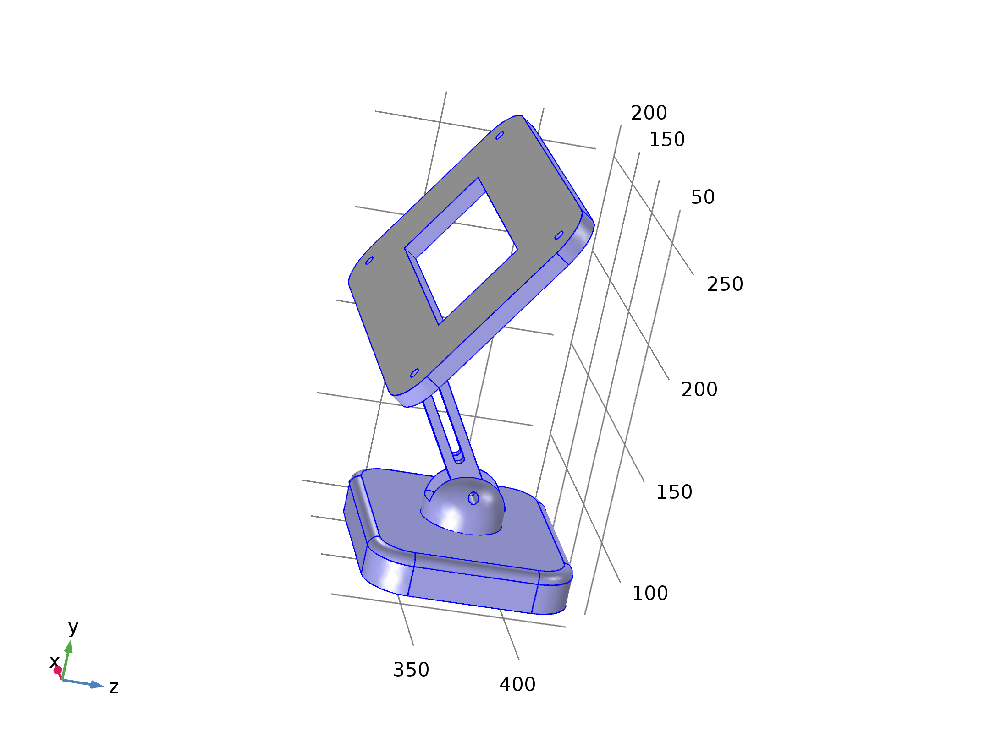
Free 1
Selection
Geometric entity level | Boundary
Selection | Boundaries 1–2, 4–83

    - Initial Values 1
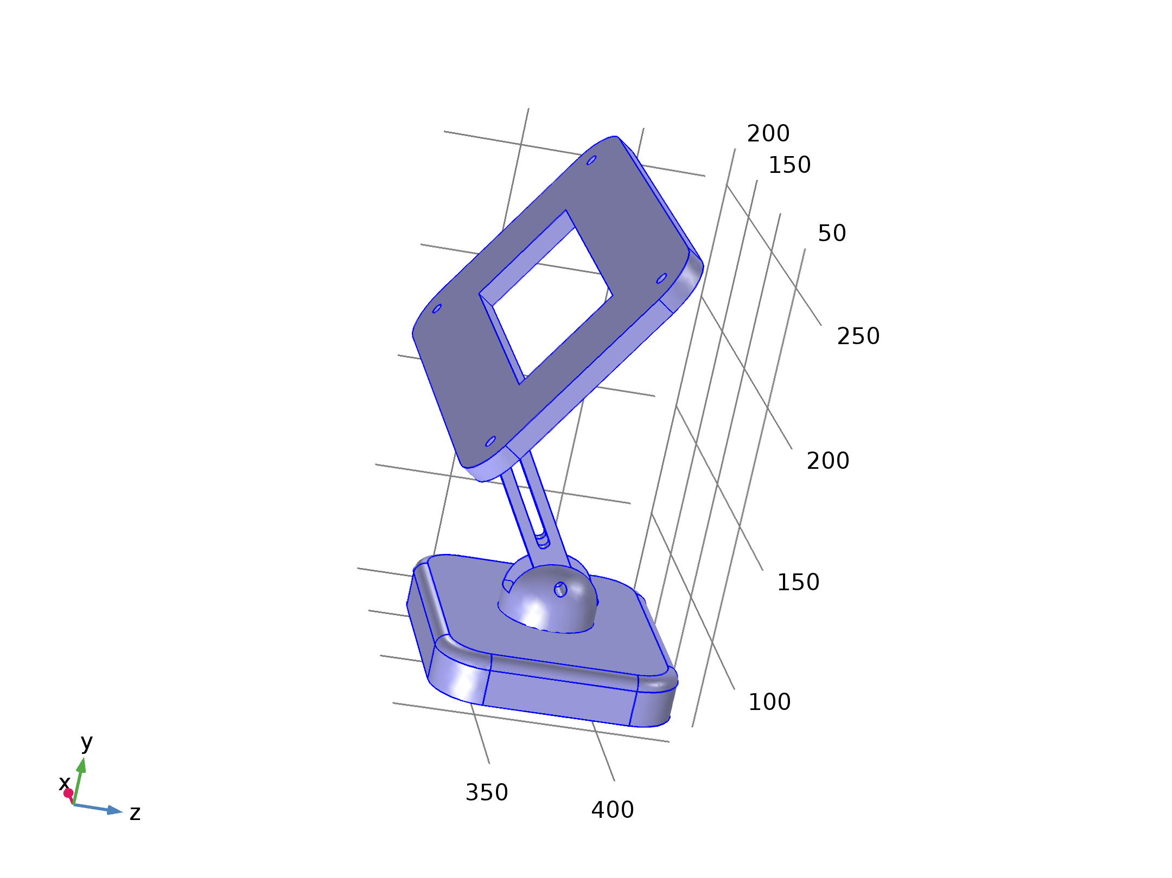
Initial Values 1
Selection
Geometric entity level | Domain
Selection | Domains 1–4

Variables
Name | Expression | Unit | Description | Selection
solid.uInitx | 0 | m | Initial value of displacement, x component | Domains 1–4
solid.uInity | 0 | m | Initial value of displacement, y component | Domains 1–4
solid.uInitz | 0 | m | Initial value of displacement, z component | Domains 1–4
solid.utInitx | 0 | m/s | Initial value of structural velocity, x component | Domains 1–4
solid.utInity | 0 | m/s | Initial value of structural velocity, y component | Domains 1–4
solid.utInitz | 0 | m/s | Initial value of structural velocity, z component | Domains 1–4

    - Boundary Load 1
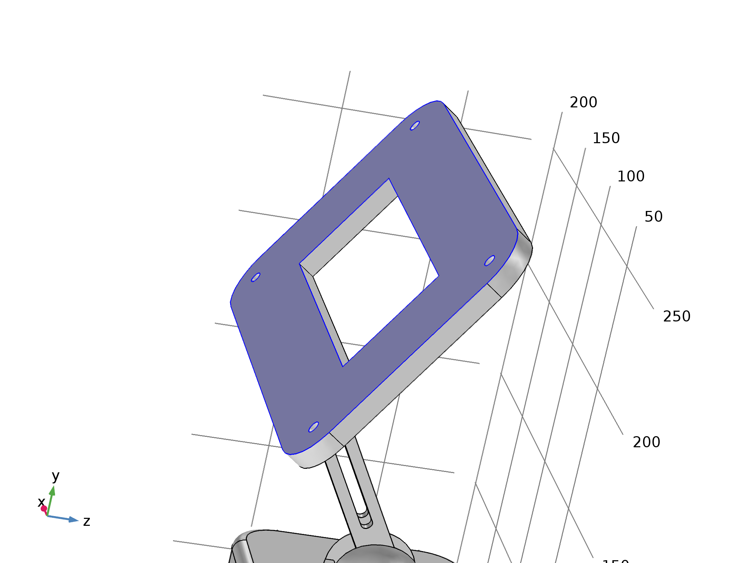
Boundary Load 1
Selection
Geometric entity level | Boundary
Selection | Boundary 3

Equations
Settings
Description | Value
Load type | Load defined as force per unit area
Load | User defined
Load | {0, -0.025, 0}

Variables
Name | Expression | Unit | Description | Selection
solid.bndl1.ux | u | m | Displacement, x component | Boundary 3
solid.bndl1.uy | v | m | Displacement, y component | Boundary 3
solid.bndl1.uz | w | m | Displacement, z component | Boundary 3
solid.bndl1.FperAreax | 0 | N/m² | Load, x component | Boundary 3
solid.bndl1.FperAreay | -0.025 | N/m² | Load, y component | Boundary 3
solid.bndl1.FperAreaz | 0 | N/m² | Load, z component | Boundary 3
solid.bndl1.FAx | solid.bndl1.FperAreax | N/m² | Load, x component | Boundary 3
solid.bndl1.FAy | solid.bndl1.FperAreay | N/m² | Load, y component | Boundary 3
solid.bndl1.FAz | solid.bndl1.FperAreaz | N/m² | Load, z component | Boundary 3
solid.FperAreax | solid.bndl1.FAx | N/m² | Load, x component | Boundary 3
solid.FperAreay | solid.bndl1.FAy | N/m² | Load, y component | Boundary 3
solid.FperAreaz | solid.bndl1.FAz | N/m² | Load, z component | Boundary 3

Weak expressions
Weak expression | Integration order | Integration frame | Selection
solid.bndl1.FAx*test(solid.bndl1.ux)+solid.bndl1.FAy*test(solid.bndl1.uy)+solid.bndl1.FAz*test(solid.bndl1.uz) | 4 | Material | Boundary 3

    - Fixed Constraint 1
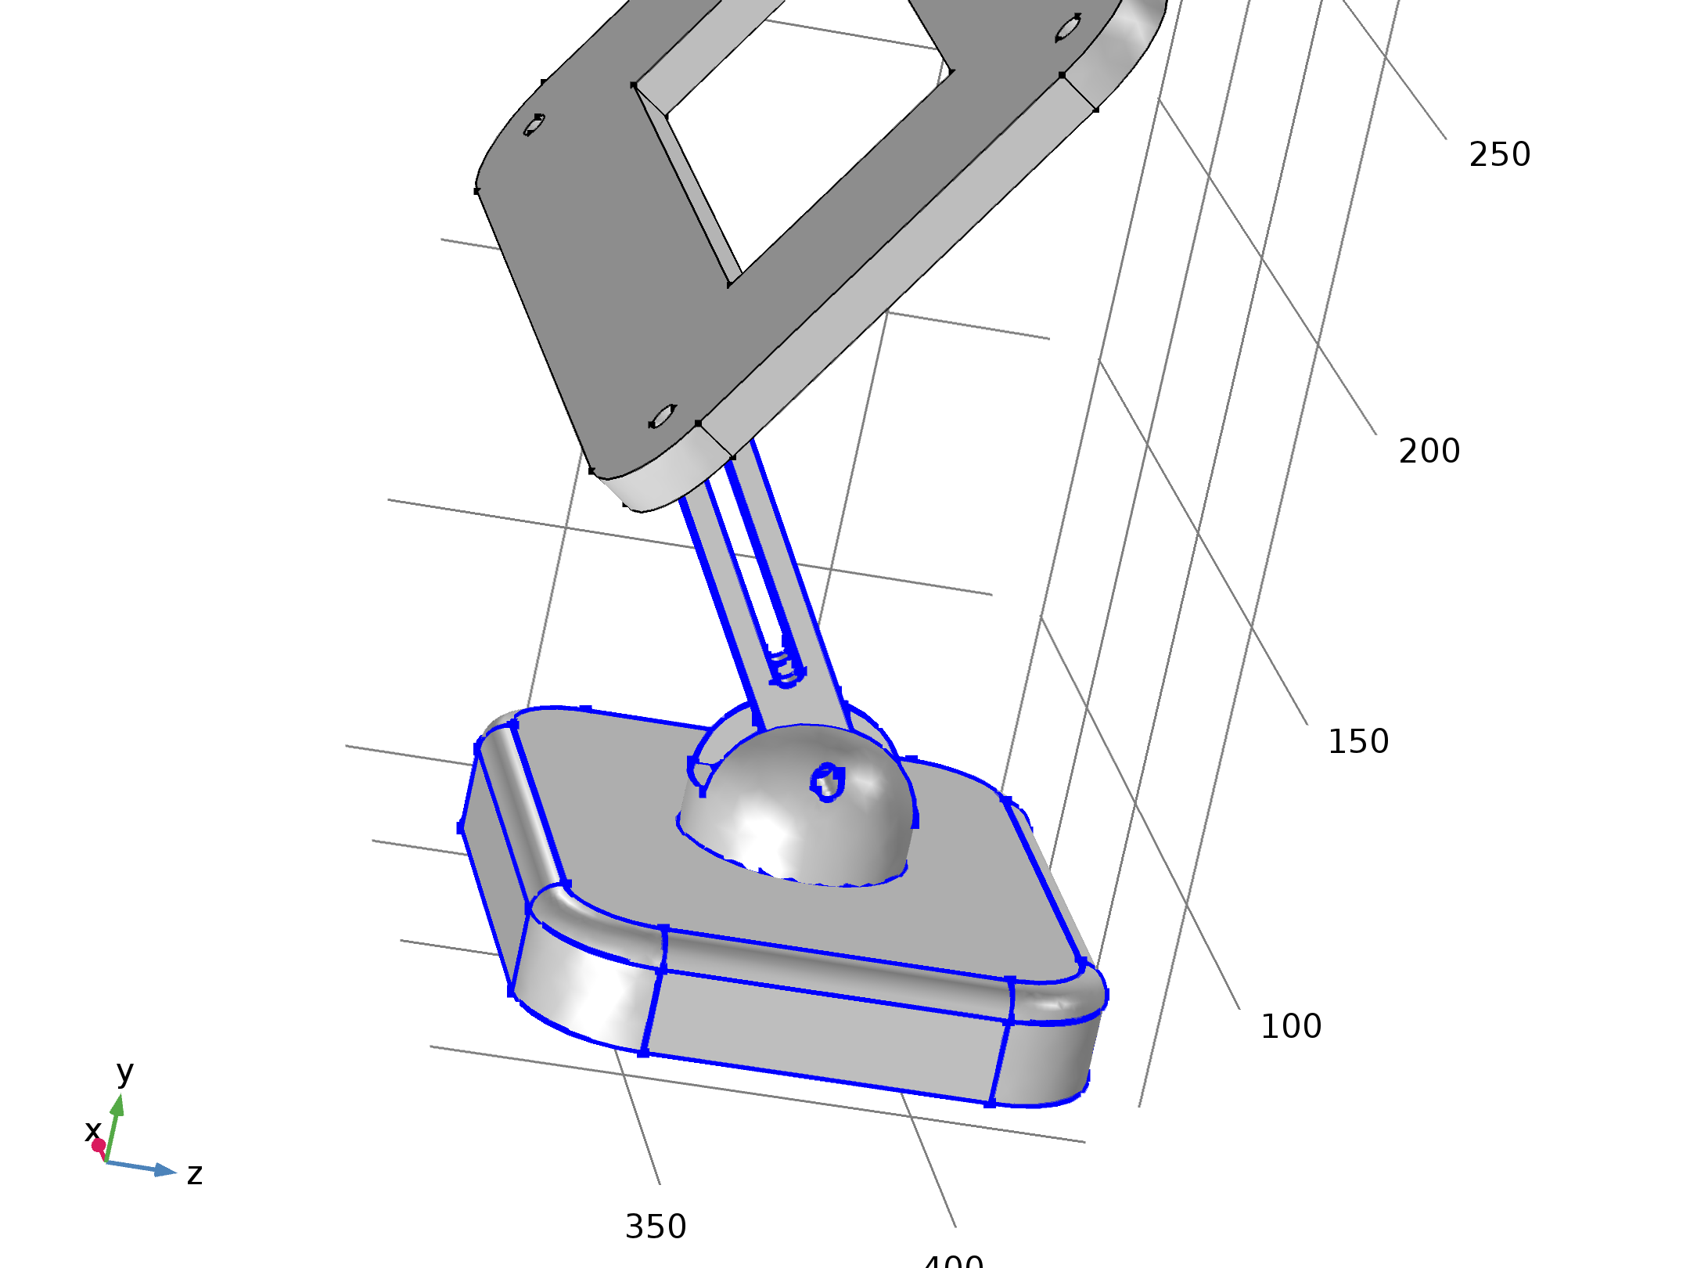
Fixed Constraint 1
Selection
Geometric entity level | Edge
Selection | Edges 31–50, 73–148, 150, 152–204, 207–216

Equations
Settings
Description | Value
Apply reaction terms on | All physics (symmetric)
Use weak constraints | Off
Constraint method | Elemental

Variables
Name | Expression | Unit | Description | Selection
solid.fix1.usx | u | m | Displacement, spatial coordinate system, x component | Edges 31–50, 73–148, 150, 152–204, 207–216
solid.fix1.usy | v | m | Displacement, spatial coordinate system, y component | Edges 31–50, 73–148, 150, 152–204, 207–216
solid.fix1.usz | w | m | Displacement, spatial coordinate system, z component | Edges 31–50, 73–148, 150, 152–204, 207–216

Shape functions
Constraint | Constraint force | Shape function | Selection
-solid.fix1.usx | test(-solid.fix1.usx) | Nodal serendipity (Quadratic) | Edges 31–50, 73–148, 150, 152–204, 207–216
-solid.fix1.usy | test(-solid.fix1.usy) | Nodal serendipity (Quadratic) | Edges 31–50, 73–148, 150, 152–204, 207–216
-solid.fix1.usz | test(-solid.fix1.usz) | Nodal serendipity (Quadratic) | Edges 31–50, 73–148, 150, 152–204, 207–216

  - Mesh 1
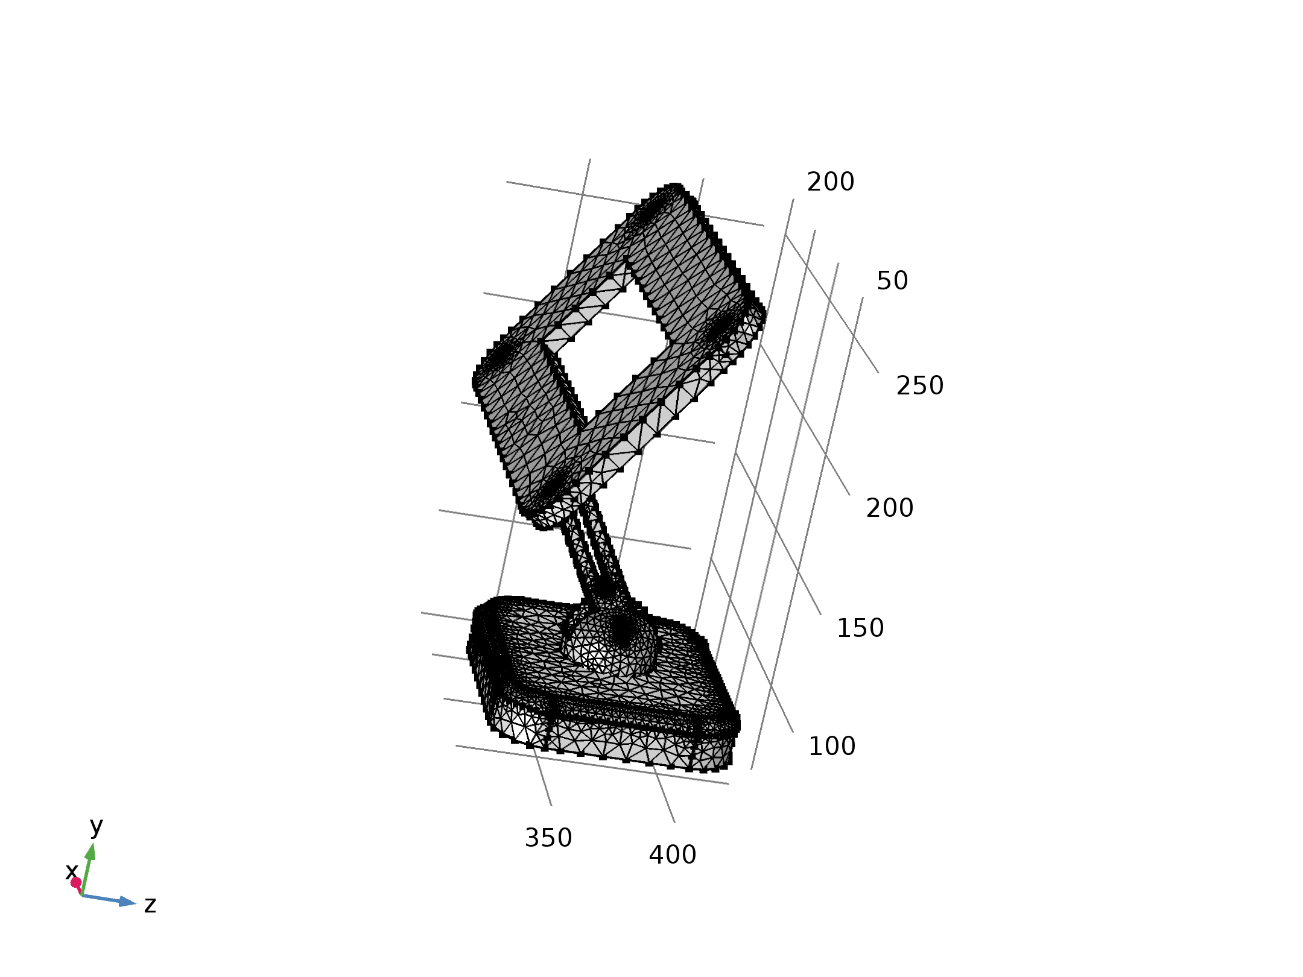
Mesh 1
    - Size (size)
Settings
Description | Value
Maximum element size | 11.2
Minimum element size | 0.816
Curvature factor | 0.4
Resolution of narrow regions | 0.7
Maximum element growth rate | 1.4
Predefined size | Finer

    - Free Tetrahedral 1 (ftet1)
Selection
Geometric entity level | Remaining


Free Tetrahedral 1
- Study 1
Computation information
Computation time | 18 s
CPU | Intel(R) Core(TM) i7-14700, 28 cores
Operating system | Windows 10

  - Stationary
Study settings
Description | Value
Include geometric nonlinearity | On

Physics and variables selection
Physics interface | Discretization
Solid Mechanics (solid) | physics

Mesh selection
Geometry | Mesh
Geometry 1 (geom1) | mesh1

  - Solver Configurations
    - Solution 1

Compile Equations: Stationary (st1)
Study and step
Description | Value
Use study | Study 1
Use study step | Stationary

Dependent Variables 1 (v1)
General
Description | Value
Defined by study step | Stationary

Displacement field (Material) (comp1.u) (comp1_u)
General
Description | Value
Field components | {comp1.u, comp1.v, comp1.w}

Stationary Solver 1 (s1)
General
Description | Value
Defined by study step | Stationary

Fully Coupled 1 (fc1)
General
Description | Value
Linear solver | Direct

- Results
  - Data Sets
    - Study 1/Solution 1
Solution
Description | Value
Solution | Solution 1
Component | Save Point Geometry 1

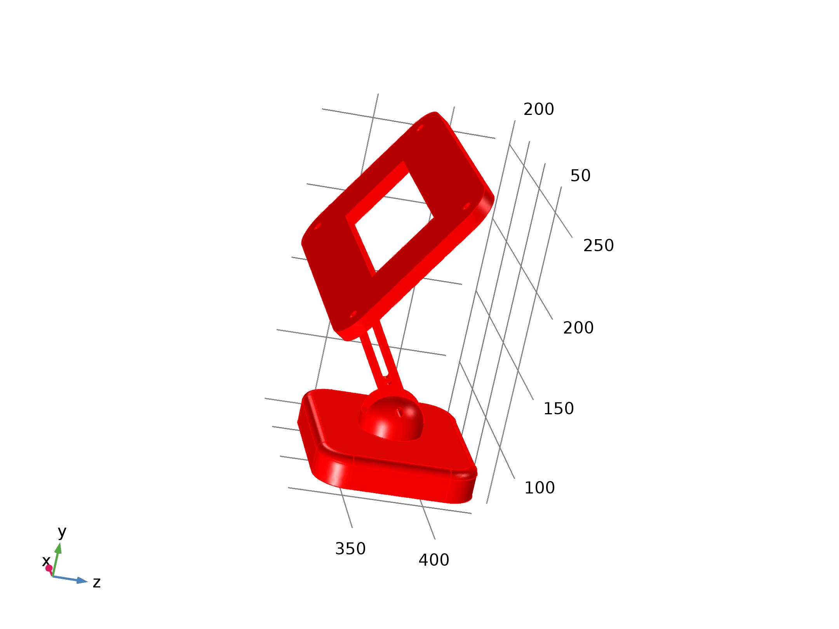
Data set: Study 1/Solution 1
  - Plot Groups
    - Stress (solid)
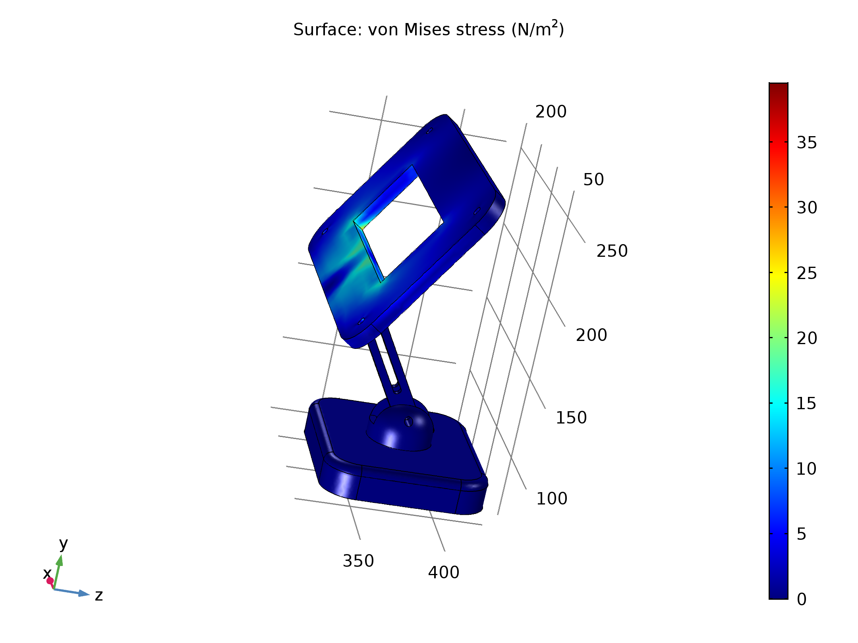
Surface: von Mises stress (N/m²)

